Chicago Community Mennonite Church

November 16, 2014 ✢ Difficult Scriptures Series

Gathering

Prelude

Call to Worship

**All: God of love,**

**light a flame of love in our hearts to you.**

**We gather this morning to be church.**

**Bless each of us here that we may,**

**choose justice by your Spirit,**

**draw kindness from the well of your mercy,**

**and walk humbly in your path, O God.**

**Amen.**

STJ 13 *My soul is filled with joy*

Welcome

Lighting the Peace Lamp

Prayer for Peace

Praising

STJ 27 *God of the Bible*

Psalm 84

Children’s Time

*Let the children come to me; let the children come.*

*Never hinder them; never stop them. O let the children come.*

Receiving God’s Word

STJ 61 *How can we be silent*

Mark 10:17-31

One: For the word of God in Scripture,

for the word of God among us,

for the word of God within us,

**All: thanks be to God.**

Meditation

Responding

HWB 395 *Here I am Lord*

Spotlight on Colombia

Sharing

Prayer

Offering

Sending

Announcements

STS 39 *Will you come and follow me*

Benediction

Extinguishing the Peace Lamp

One: Now the light of Christ is in you.

**All: Thanks be to God.**

|  |
| --- |
| Worship Participants  Worship Leader: Sara Reschly  Meditation: Megan Ramer  Song Leader: Beth Peachey  Pianist: Antonia Kam  Altar: Jody Schmidt |

Announcements

**Second Hour Fall Series: Bringing Peace Home:** Today Bob Hostetter presents “Peace After Gaza: The Changing Face of Conflict in Israel-Palestine”. Join us for an orientation to the Israel-Palestine conflict and the possibilities for a just peace after the war in Gaza.

**Annual Bake Sale Fundraiser Today:** All proceeds will go towards our goal to fundraise $1000 for the ministry of William and Marina Valencia in Columbia. If you can't attend, you can make a donation to CCMC and write "Colombia Mission Fund" in the memo line!

**Ordination Feast, December 13th:** CCMC will host a meal following Celeste Groff's ordination for the church and Celeste's family, friends, and colleagues. If you would like to help organize, cook or help on the day please let Leigh Peters-Fransen know.

**Looking for a Parachute or HUGE Piece of Fabric:** The worship planning team for the **Fabulous, Fierce & Sacred** conference is looking to borrow a parachutes (the type kids use in gym class) or an otherwise exceedingly large piece of fabric. If you could loan either to a responsible group of adults, please email Annabeth Roeschley at [abroeschley@gmail.com](mailto:abroeschley@gmail.com). The conference is also seeking **help with childcare** on Saturday, November 22. Contact Hannah Klaassen if you can help: hannah.klaassen@gmail.com, 316-772-3671.

**Advent Cookie Party, December 6th, 4 PM:** The Peters-Fransens will host the annual CCMC cookie party at 115 Elgin Ave in Forest Park. The cookie ceremonies will be followed by a pizza dinner at 6 PM and then the classic Grinch and a second holiday movie. Please RSVP with Joel or Leigh Peters-Fransen ([petersfransen@gmail.com](mailto:petersfransen@gmail.com)).

**Annual Meeting: December 7th:** This year's Annual Meeting will take place on Sunday, December 7th following our potluck.

**Beer Group, December 13th, 6 PM:** Beer Group will meet at Amber and Matthew's in Oak Park, 911 South Oak Park Avenue (2nd floor). More details soon.

**Christian Peacemaker Teams Prayer for Peacemakers:** Pray for the CPT’s Aboriginal Justice Team who are exploring decolonizing their work by learning Anishinabek and Haudenosaunee languages.

Schedule

|  |  |  |
| --- | --- | --- |
|  | **Today** | **Next Sunday** |
| **Greeter:** | Russell Johnson | Ross Bay |
| **Nursery:** | Cecilia Goertzen  Justin Riegsecker | Justin Hochstetler  Laura Hostetler |
| **Fellowship:** | Josiah Groff | Spencer Foon  Geoff Martin |
| **Welcome Table:** | Merle Baker  Rosalynn Gingerich | Ruby Y Campos  Spencer Foon |

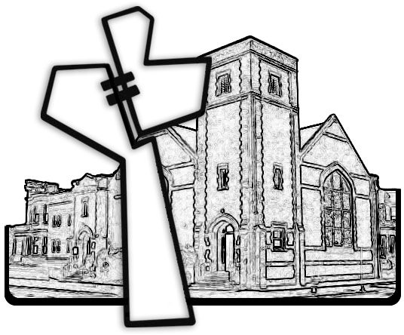



Chicago Community Mennonite Church

425 S. Central Park Blvd. (at Congress), Chicago, Illinois 60624-3224

www.ccmcil.org **|** facebook.com/ccmcil

**Church Council Chair:** Jason Gerig, 773-949-4496, jgerig@gmail.com

**Pastor:** Megan Ramer, 773-343-4251, pastor@ccmcil.org

Chicago Community Mennonite Church

November 16, 2014