Chicago Community Mennonite Church

October 19, 2014 ✢ Proper 24

Gathering

Prelude

Call to Worship

One: God has shown us the meaning of generosity

**Many: in the rich diversity of creation,**

**in the overflowing love of Jesus Christ,**

**the never-ending gift of the Holy Spirit.**

One: God has abundantly blessed us and called us

**Many: to be a community that honors each other,**

**to be servants to others with joy,**

**to share our love and material possessions.**

***All***: ***Let us rejoice in what we have been given and in what is ours to give.***

HWB 6 *Here in this place*

Welcome

Lighting the Peace Lamp

Praising

Psalm 96

Children’s Time

*Let the children come to me; let the children come.*

*Never hinder them; never stop them. O let the children come.*

Christians and Money Joel Peters-Fransen

Receiving God’s Word

Isaiah 45:1-7

1 Thessalonians 1:1-10

HWB 386 *As saints of old*

Matthew 22:15-22

One: For the word of God in Scripture, for the word of God among us, for the word of God within us,

**All: thanks be to God.**

Meditation

Responding

HWB 383 *God, whose giving*

Offering

Special Music Luciano Lima

Sharing

Sending

Announcements

HWB 388 *Grant us, Lord, the grace*

Benediction

Extinguishing the Peace Lamp

One: Now the light of Christ is in you.

**All: Thanks be to God.**

|  |
| --- |
| Worship Participants  Worship Leader: Brian & Maria Paff  Meditation: Megan Ramer  Song Leader: Mariell Waltner  Pianist: Antonia Kam  Altar: Jody Schmidt |

Announcements

**Time and Talent 2015 Due Today:** We've arrived at the time of year when we reflect on the ways we might share our time and talents with each other and our community. This year's survey is available on the church website under "Community." Please plan to complete the survey today.

**House Church Sunday, next week, Oct 26:** Gather in a home near you for worship at 10:00 followed by a potluck brunch. **There will be NO service at the building.** Everyone is welcome! Locations:

* West: Joel & Leigh Peters-Fransen, 115 Elgin Ave, Forest Park, (708) 689-8096
* South: Janet & Lauren Friesen, 5555 S Everett Ave, E6, Chicago, (810) 282-1503
* North: Nancy & Bob Hostetter, 2908 W Catalpa Ave, Chicago, (773) 784-7457

**Annual Meeting: Save the Date:** This year's Annual Meeting will take place on Sunday, December 7th following our potluck. Stay tuned for more information!

**Get to Know/Feed the MVSers:** Help our new group of MVSers feel at home by signing up to host the group for a meal (or any other fun activity)! Please email Mark Vanderhoff (mdvanderhoff@yahoo.com) with your preferred month (now through August 2015) and any questions. Specific dates will be worked between hosts and the MVSers.

**India Mission Fund:** CCMC is supporting a young Indian woman, Samita Pal, in obtaining her nurses training. The full cost will be approximately $2350, including fees for her uniform and supplies. So far we have $800, or one-third of the amount, covered through pledges. If you feel moved to contribute to this opportunity, please inform Paul Myers or simply write a check to CCMC and include “India Mission Fund” on the memo portion of the check. Funds for ongoing support of Anita's health and mission work are will also happily be accepted.

**Christian Peacemaker Teams Prayer for Peacemakers:** Pray for all who stand up for human rights in Colombia.  The leading Colombian newspaper, *El Espectador*, says that aggressions against human rights defenders are up 170% from last year.

Schedule

|  |  |  |
| --- | --- | --- |
|  | **Today** | **Next Sunday** |
| **Greeter:** | Geoff Martin | House Church |
| **Nursery:** | Allison Schuler  Russell Johnson | House Church |
| **Fellowship:** | Ross Bay | House Church |
| **Welcome Table:** | Jane Baker  Jason Gerig | House Church |

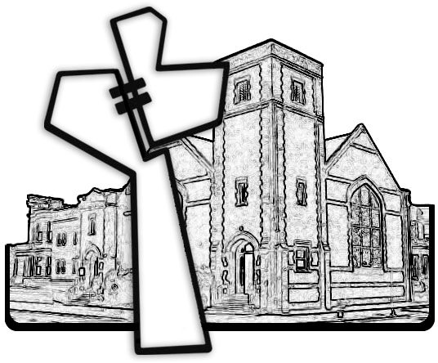



Chicago Community Mennonite Church

425 S. Central Park Blvd. (at Congress), Chicago, Illinois 60624-3224

www.ccmcil.org **|** facebook.com/ccmcil

**Church Council Chair:** Jason Gerig, 773-949-4496, jgerig@gmail.com

**Pastor:** Megan Ramer, 773-343-4251, pastor@ccmcil.org

Chicago Community Mennonite Church

October 19, 2014