Chicago Community Mennonite Church

October 12, 2014 ✢ Proper 23

Gathering

Prelude

Call to Worship

Typhoons and floods and environmental havoc;  
**drones and IEDs and handguns;**  
cancer and heart disease and bodies shutting down;  
**poverty and injustice and oppression.**  
The ways of death in this world are many.  
**The words of death surround us.**  
The fear of death envelopes us.  
**But we come now to hear a different Word,**  
a true Word  
**a life-giving Word.**  
We are here on Isaiah’s mountain  
**where tears are wiped away,**  
where a banquet table has been set,  
**where death has been swallowed up forever.**  
We do not fully understand it.  
**We may not fully believe it.**  
And yet here it is:  
**the power of Christ’s life within us and among us.**  
***So let us be glad and rejoice in our salvation!***

STJ 71 *Alleluia, the Great Storm is over*

Welcome

Praising

Lighting the Peace Lamp

Prayer for Peace

HWB 495 *O let all who thirst*

Isaiah 25:1-9

Children’s Time

*Let the children come to me; let the children come.*

*Never hinder them; never stop them. O let the children come.*

STJ 41 *Alleluia*

Receiving God’s Word

Philippians 4:1-9

Matthew 22:1-14

One: For the word of God in Scripture, for the word of God among us, for the word of God within us,

**All: thanks be to God.**

Meditation

Responding

HWB 587 *Come, my Way, my Truth, my Life*

Sharing

Prayer

Archaeology of our Faith

Sending

Announcements

HWB 395 *Here I am, Lord*

Benediction

Extinguishing the Peace Lamp

One: Now the light of Christ is in you.

**All: Thanks be to God.**

**One: Now the light of Christ is in you.**

All: Thanks be to God.

|  |
| --- |
| Worship Participants  Worship Leader: Megan Ramer  Song Leader: Glenn Martin Klaassen  Pianist: Beth Peachey  Altar: Janet Friesen |

Announcements

**Gluten Free: Setting the Table for Everyone:** Ever wonder what gluten is or why it matters? Join us during Second Hour today (in the Fellowship Hall) for a time of sharing and discussion as we identify different forms of gluten intolerance and create a plan to inclusively care for our community's mealtime needs.

**House Church Sunday, October 26:** Gather in a home near you for worship at 10:00 followed by a potluck brunch. There will be no service at the building. Everyone is welcome! Locations:

* West: Joel & Leigh Peters-Fransen, 115 Elgin Ave, Forest Park, (708) 689-8096
* South: Janet & Lauren Friesen, 5555 S Everett Ave, E6, Chicago, (810) 282-1503
* North: Nancy & Bob Hostetter, 2908 W Catalpa Ave, Chicago, (773) 784-7457

Want to participate in the worship and/or music? Contact your worship leaders: West, Merle & Jane Baker; South, Beth Peachey & Rachael Weasley; North: Glenn & Ro Martin Klaassen

**Get to Know/Feed the MVSers:** Help our new group of MVSers feel at home by signing up to host the group for a meal (or any other fun activity)! Please email Mark Vanderhoff with your preferred month (now through August 2015) and any questions. Specific dates will be worked between hosts and the MVSers. mdvanderhoff@yahoo.com

**Christian Peacemaker Teams Prayer for Peacemakers:** Pray for the children of Hebron’s Old City who are subject to arbitrary arrest and detention without due process and since the start of the school year, have had more than 100 tear gas grenades fired at them.

Schedule

|  |  |  |
| --- | --- | --- |
|  | **Today** | **Next Sunday** |
| **Greeter:** | Jason Gerig | Geoff Martin |
| **Nursery:** | Jane Baker  Janet Friesen | Allison Schuler  Russell Johnson |
| **Fellowship:** | Spencer Foon  Geoff Martin | Ross Bay |
| **Welcome Table:** | Geoff Martin  Hannah Klaassen | Jane Baker  Jason Gerig |

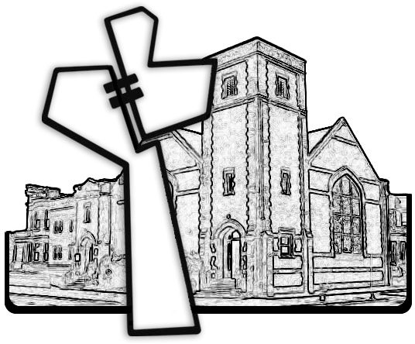



Chicago Community Mennonite Church

425 S. Central Park Blvd. (at Congress), Chicago, Illinois 60624-3224

www.ccmcil.org **|** facebook.com/ccmcil

**Church Council Chair:** Jason Gerig, 773-949-4496, jgerig@gmail.com

**Pastor:** Megan Ramer, 773-343-4251, pastor@ccmcil.org

Chicago Community Mennonite Church

October 12, 2014