Chicago Community Mennonite Church

September 7, 2014 ✢ Season of Creation: Forest Sunday

Gathering

Prelude

Call to Worship

One: We invite the forests to worship with us:

**All: mountain ash and vibrant maples,**

**Quivering ferns and glistening moss!**

One: We invite tall trees to celebrate life:

**All: to lift green leaves in the breeze**

**and sing their oxygen into the air.**

One: We call the forest to sing in the night:

**All: green tree frogs and timid moths,**

**Butterflies and swirling bats!**

One: We join with the fauna of the forest in praising God:

**All: redwinged blackbirds and hummingbirds,**

**creeping things and butterflies.**

One: We celebrate the song of the forest!

**All: Sing, forest, sing!**

Welcome

Lighting the Peace Lamp

Prayer for Peace

Praising

HWB 648 *Morning has broken*

Children’s Time

*Let the children come to me; let the children come. Never hinder them; never stop them. O let the children come.*

Blessing of Backpacks and Calendars

Receiving God’s Word

Psalm 139

HWB 46 *I sing the mighty power of God*

Genesis 2:4b-22

One: For the word of God in scripture,   
for the word of God among us,   
for the word of God within us,

**All: thanks be to God.**

Meditation

Responding

STS 116 *I saw a tree by the riverside*

Offering

Sharing

Prayer

Prayer of Commissioning for Kiva Nice-Webb

Sending

Announcements

HWB 427 *You shall go out with joy*

Benediction

Extinguishing the Peace Candle

**One: Now the light of Christ is in you.**

All: Thanks be to God.

|  |
| --- |
| Worship Participants  Worship Leader: Jan Lugibihl  Meditation: Megan Ramer  Song Leader: Philip Kendall  Pianist: Hannah Klaassen  Altar: Brooke Hutchison |

Announcements

**Vision Gathering** is an opportunity for our church to consider what our future may hold. We'll meet today immediately following potluck (noon) until 2:30PM.  This year our theme is "love extravagantly." May we all consider ways in which we as individuals and collectively can love more extravagantly. Childcare will be provided.

**Save the date:** Mark your calendars now for our second annual "Wine Down" event with DOOR Chicago, Thurs Oct 9, 6-9pm, at Inspiration Kitchens in East Garfield Park. Plan for an evening of good food & wine, great conversation, and both new & old friends. All proceeds will benefit the local youth participating and developing leadership capacities in our program. Invest in our youth, invest in our city. ~Pastor Megan, co-chair of the DOOR Chicago board

**Apple Party:** Apple picking & potluck in Michigan will be Saturday October 11. Mark your calendars now. More details to come.

**Ted & Co., *Listening for Grace*, September 27, 2:00 p.m.:** We are hosting Ted Swartz's newest show. The performance will be held in our sanctuary and followed by a talk back. Ted uses his distinctive humor to give voice to our fears and hopes when a faith community engages in questions around sexuality. It’s about a father’s journey, a church’s struggle and a search for commonality.

**Small Group Peace Study:** All are invited to join Michael and Barbara Sacco at their house one Sunday a month for a meal and bible study focused on peace and conflict resolution. Our first meeting will be on **Sunday, September 14**. If you’d like to participate or need more information, please contact Michael or Barbara. mjsacco@att.net, bsacco63@yahoo.com

Schedule

|  |  |  |
| --- | --- | --- |
|  | **Today** | **Next Sunday** |
| **Greeter:** | Liz Finch | Derek Becker |
| **Nursery:** | Rochelle Martin-Klaassen  Josiah Groff | Linda Becker  Martin Dyrst |
| **Fellowship:** |  |  |
| **Welcome Table:** |  | Brian Paff  Maria Paff |

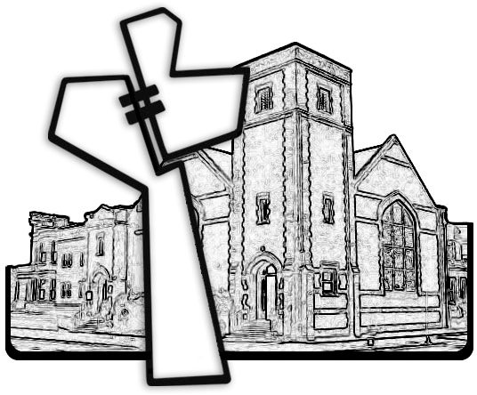



Chicago Community Mennonite Church

425 S. Central Park Blvd. (at Congress), Chicago, Illinois 60624-3224

www.ccmcil.org **|** facebook.com/ccmcil

**Church Council Chair:** Jason Gerig, 773-949-4496, jgerig@gmail.com

**Pastor:** Megan Ramer, 773-343-4251, pastor@ccmcil.org

Chicago Community Mennonite Church

September 7, 2014