Chicago Community Mennonite Church

September 28, 2014 ✢ Season of Creation: Wilderness Sunday

Gathering

Prelude

Call to Worship

One:    We invite the wilderness to worship with us:

**All:     thickets and rugged terrain,**

**deep gorges and mountain ranges.**

One:    We invite the hot sands to celebrate life:

**All:   to lift their voices to our God**

**at the sound of rain on the dust.**

One:     We invite the flora to sing in the sun:

**All:      cactus and tumbleweed, brush and bristle.**

One:     We join with the fauna of the wilderness in praising God:

**All:      lizards and gila monsters,**

**rattlesnakes and hovering hawks.**

One:     We invite the spirits of the wilderness to join us in praise:

**All:      songs of ancient custodians deep in the rock,**

**spirits of life deep in the sand and the hills.**

One:     We celebrate the song of the wilderness!

**All:      Sing, wilds, sing!**

HWB 16 *God is here among us*

Welcome

Lighting the Peace Lamp

Praising

HWB 53 *God of the earth, the sky, the sea*

Psalm 18:1-19

Blessing a new mentor pair: Josiah Groff & Jared Klaassen

Children’s Time

*Let the children come to me; let the children come. Never hinder them; never stop them. O let the children come.*

STS 39 *Will you come and follow me*

Receiving God’s Word

Joel 1:8-10, 17-20; Romans 8:18-27

STS 36 *Jesus tempted in the desert*

Mark 1:9-13

One: For the word of God in scripture,   
for the word of God among us,   
for the word of God within us,

**All: thanks be to God.**

Meditation

Responding

STS 121 *Nothing is lost on the breath of God*

Sharing

Communion

Sending

Announcements

STS 124 *My soul cries out*

Benediction

One:    Christ calls you to be his disciples,

to serve him with love and compassion,

to serve Earth by caring for creation,

especially in the wilderness that God has created

to evoke in us awe and wonder and praise.

**All:     we will follow our Lord, the crucified Christ,**

**we will listen for cries of injustice from Earth,**

**we will groan with a creation burdened by sin.**

**we will follow our Lord, the risen Christ,**

**we will be partners with Christ**

**in healing our planet,**

**we will join the Wounded Healer**

**as he restores all things.**

**we will care for creation, we will nurture the wilderness.**

**we will love our kin.**

**we will celebrate life.**

Extinguishing the Peace Candle

**One: Now the light of Christ is in you.**

All: Thanks be to God.

|  |
| --- |
| Worship Participants  Worship Leader: Mark Frey  Meditation: Carol Rose  Song Leader: Dan Bertsche  Pianist: Steve Warkentin  Altar: Janet Friesen |

Announcements

**Get to Know/Feed the MVSers:** Help our new group of MVSers feel at home by signing up to host the group for a meal (or any other fun activity)! Please email Mark Vanderhoff (mdvanderhoff@yahoo.com) with your preferred month (now through August 2015) and any questions. Specific dates will be worked between hosts and the MVSers.

**Beer Small Group – Today:** Celebrate Oktoberfest at this month's gathering of the beer small group tonight at 6:00 pm at Maria and Brian Paff's apartment. Bring your favorite Bavarian-style beer (Oktoberfest, Hefeweizen, Dunkel, etc.) to share.

**World Communion worship & potluck, October 5, 10:00 a.m.**

We will worship at 10:00 a.m. (sleep in an extra hour!) with our sister congregations, First Church of the Brethren and La Roca de Esperanza. Our preacher will be Sarah Thompson, the new Executive Director of Christian Peacemaker Teams. Following worship we will have a joint potluck together. Stick around for a presentation by **Colombian peacemaker, Mario Cardozo, at 1:00 p.m.** After declaring himself a Conscientious Objector at 18 years old, Mario Cardozo began working with Acción Colectiva de Objetores y Objetoras de Consciencia (ACOOC – the Collective Action for Conscientious Objectors), to develop strategies in support of conscientious objection, anti-militarization, and active nonviolence in Colombia. Together, they have created and shared these ideas through theater and music. Mario is in the States to receive the Muhammad Ali humanitarian award and is coming to us as part of a speaking tour arranged by the Fellowship of Reconciliation.

**House Church Sunday, October 26:** Gather in a home near you for worship at 10:00 followed by a potluck brunch. There will be no service at the building. Everyone is welcome! Locations: **West**: Joel & Leigh Peters-Fransen, 115 Elgin Ave, Forest Park, (708) 689-8096; **South**: Janet & Lauren Friesen, 5555 S Everett Ave, E6, Chicago, (810) 282-1503; **North**: Nancy & Bob Hostetter, 2908 W Catalpa Ave, Chicago, (773) 784-7457

Schedule

|  |  |  |
| --- | --- | --- |
|  | **Today** | **Next Sunday** |
| **Greeter:** | Jan Lugibihl | Julia Rohan |
| **Nursery:** | Joel Peters Fransen  Ross Bay | Cecilia Goertzen  Kate Myers |
| **Fellowship:** | Paul Myers | Katie VanderHeide  Russell Johnson |
| **Welcome Table:** | Derek Becker  Mark Liechty | Potluck |

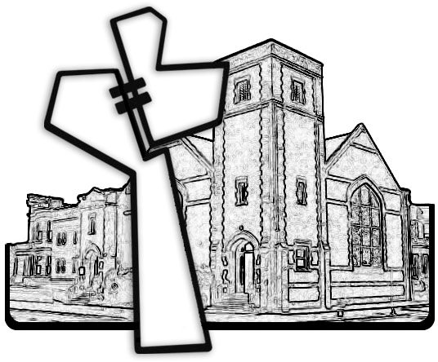



Chicago Community Mennonite Church

425 S. Central Park Blvd. (at Congress), Chicago, Illinois 60624-3224

www.ccmcil.org **|** facebook.com/ccmcil

**Church Council Chair:** Jason Gerig, 773-949-4496, jgerig@gmail.com

**Pastor:** Megan Ramer, 773-343-4251, pastor@ccmcil.org

Chicago Community Mennonite Church

September 28, 2014