Chicago Community Mennonite Church

September 21, 2014 ✢ Season of Creation: River Sunday

Gathering

Prelude

Call to Worship

One:    We invite the rivers to worship with us:

**All:     the Mississippi, the Chicago,**

**and all the rivers that flow to the sea.**

One:    We invite the streams to sing:

**All:   perch, sunfish, and flashing bass,**

**trout streams and gleaming fountains.**

One:    We invite the fauna to praise God with us:

**All:      loon, heron, and mallard duck,**

**dragonflies and sleepy tortoises.**

One:    We join with the waters in praising God:

**All:     waterfalls singing upstream**

**and ripples dancing at the river mouth.**

One:    We celebrate the song of the river!

**All:      Sing, river, sing!**

HWB 46 *I sing the mighty power of God*

Welcome

Lighting the Peace Lamp

Prayer for Peace

Praising

Psalm 104:27-33

HWB 336 *When peace like a river*

Children’s Time

*Let the children come to me; let the children come. Never hinder them; never stop them. O let the children come.*

Receiving God’s Word

Genesis 8:20-22; 9:12-17

Revelation 22:1-5

One: For the word of God in scripture,   
for the word of God among us,   
for the word of God within us,

**All: thanks be to God.**

Meditation

Responding

STJ 49 *Rain down*

Offering

Commissioning Incoming MVSers

Sharing

Prayer

Sending

Announcements

STS 57 *Go my friends, in grace*

Benediction

Extinguishing the Peace Candle

**One: Now the light of Christ is in you.**

All: Thanks be to God.

|  |
| --- |
| Worship Participants  Worship Leader: Justin Beeker  Meditation: Megan Ramer  Song Leader: Beth Peachey  Pianist: Antonia Kam  Altar: Jody Schmidt |

Announcements

**World Communion Service, October 5, 10:00 a.m.:** We will worship at 10:00 a.m. (sleep in an extra hour!) with our sister congregations, First Church of the Brethren and La Roca de Esperanza. Following worship we will have a joint potluck. Please bring a dish to share.

**House Church Sunday, October 26:** Gather in a home near you for worship at 10:00 followed by a potluck brunch. There will be no service at the building. Everyone is welcome! Locations:

* West: Joel & Leigh Peters-Fransen, 115 Elgin Ave, Forest Park, (708) 689-8096
* South: Janet & Lauren Friesen, 5555 S Everett Ave, E6, Chicago, (810) 282-1503
* North: Nancy & Bob Hostetter, 2908 W Catalpa Ave, Chicago, (773) 784-7457

**Apple Party:** Apple picking & potluck in Michigan will be Saturday October 11. Mark your calendars now. More details to come.

**DOOR Chicago evening of fun, Thurs Oct 9, 6-9pm, Inspiration Kitchens:** Invest in our Youth, Transform our City: an evening of incredible food, passionate conversation and inspiring stories of transformation. "Wine Down" your week by bringing your favorite bottle to share in our second annual blind tasting. Taste your friends' favorite varietals to discover something new and support our mission of empowering local youth to become leaders in their Chicago communities. Tickets $20 in advance, $25 at the door (cash or check): **http://bit.ly/winedown2014.**

**Ted & Co., *Listening for Grace*, September 27, 2:00 p.m.:** We are hosting Ted Swartz's newest show. The performance will be held in our sanctuary and followed by a talk back. Ted uses his distinctive humor to give voice to our fears and hopes when a faith community engages in questions around sexuality. It’s about a father’s journey, a church’s struggle and a search for commonality. A generous donation of $2000 from one of our co-hosts, is underwriting the event. We have received $75 in contributions (thank you!) and need to raise an additional $475 to keep the show free for everyone. Please consider making your suggested $20/person donation in advance so that we can reach our goal. Checks to CCMC with "theatre" in the memo line.

Schedule

|  |  |  |
| --- | --- | --- |
|  | **Today** | **Next Sunday** |
| **Greeter:** | Brooke Hutchison | Jan Lugibihl |
| **Nursery:** | Jan Lugibihl  Mallory Dignin | Joel Peters Fransen  Ross Bay |
| **Fellowship:** | Joanne Zimmerly | Paul Myers |
| **Welcome Table:** | Megan Ramer | Derek Becker  Mark Liechty |

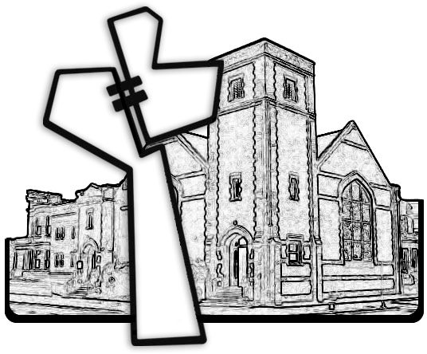



Chicago Community Mennonite Church

425 S. Central Park Blvd. (at Congress), Chicago, Illinois 60624-3224

www.ccmcil.org **|** facebook.com/ccmcil

**Church Council Chair:** Jason Gerig, 773-949-4496, jgerig@gmail.com

**Pastor:** Megan Ramer, 773-343-4251, pastor@ccmcil.org

Chicago Community Mennonite Church

September 21, 2014