Chicago Community Mennonite Church

September 14, 2014 ✢ Season of Creation: Land Sunday

Gathering

Prelude

Call to Worship

One: In the name of the Creator, the fountain of life,

**All: Holy! Holy! Holy!**

**The name of Christ, the pulse of life,**

**and the name of the Spirit, the breath of life. Amen**

**Earth is filled with God’s presence.**

One: Christ, we come into your presence

to worship with this sanctuary called Earth,

**All: a planet pulsating with your presence,**

**a presence quivering in the forests,**

**a presence vibrating in the land,**

**a presence pulsating in the wilderness,**

**a presence shimmering in the rivers.**

One: God, reveal yourself to us in this place,

and show us your face in all creation.

**All: Holy! Holy! Holy!**

**The whole Earth is filled with your glory.**

One: We invite the land to worship with us:

**All: wildflowers and mysterious mushrooms,**

**swirling grasses and goldenrods.**

One: We invite the land to sing with us:

**All: raised beds, window sill herb gardens,**

**and potted plants on porches,**

**green grasses, compost bins, and rain gardens.**

One: We join with all the fauna of the urban landscape in praising God:

**All: deer, coyotes, and rabbits,**

**grass snakes and grasshoppers,**

**pigeons and morning doves.**

One: We invite the ground to stir deep below:

**All: life-giving microbes restoring the soil,**

**Beetles and worms preparing our food.**

One: We celebrate the song of the soil!

**All: Sing, soil, sing!**

STS 122 *Let all creation dance*

Welcome

Psalm 139:7-10

HWB 154 *This is my Father’s world*

Lighting the Peace Lamp

Prayer for Peace

Praising

Children’s Time

*Let the children come to me; let the children come. Never hinder them; never stop them. O let the children come.*

Archeology of Our Faith

HWB 35 *Many and great, O God*

Receiving God’s Word

Genesis 3:14-19; 4:8-16

Matthew 12:38-40

One: For the word of God in scripture,   
for the word of God among us,   
for the word of God within us,

**All: thanks be to God.**

Meditation

Responding

Offering

Sharing

Prayer

Sending

Announcements

HWB 90 *For the fruit of all creation*

Benediction

Extinguishing the Peace Candle

**One: Now the light of Christ is in you.**

All: Thanks be to God.

|  |
| --- |
| Worship Participants  Worship Leader: Benjamin Anderson  Meditation: Megan Ramer  Song Leader: Glenn Martin Klaassen  Pianist: Joanne Zimmerly  Altar: Antonia Kam |

Announcements

**Second Hour Today - Sharing Our Spiritual Journeys:** Please join us for a time of sharing with Kurt Frymire, as he reflects on the pathways of his life journey. Whenever we listen to one another's life stories, we find ourselves on holy ground.

**Small Group Peace Study Today:** All are invited to join Michael and Barbara Sacco at their house one Sunday a month for a meal and bible study focused on peace and conflict resolution. Our first meeting will be today. If you’d like to participate or need more information, please contact Michael or Barbara. mjsacco@att.net, [bsacco63@yahoo.com](mailto:bsacco63@yahoo.com)

**Ted & Co., *Listening for Grace*, September 27, 2:00 p.m.:** We are hosting Ted Swartz's newest show. The performance will be held in our sanctuary and followed by a talk back. Ted uses his distinctive humor to give voice to our fears and hopes when a faith community engages in questions around sexuality. It’s about a father’s journey, a church’s struggle and a search for commonality.

**DOOR Chicago evening of fun, Thurs Oct 9, 6-9pm, Inspiration Kitchens:** Invest in our Youth, Transform our City: an evening of incredible food, passionate conversation and inspiring stories of transformation. "Wine Down" your week by bringing your favorite bottle to share in our second annual blind tasting. Taste your friends' favorite varietals to discover something new and support our mission of empowering local youth to become leaders in their Chicago communities. Tickets $20 in advance, $25 at the door (cash or check): **http://bit.ly/winedown2014**.

**Apple Party:** Apple picking & potluck in Michigan will be Saturday October 11. Mark your calendars now. More details to come.

Schedule

|  |  |  |
| --- | --- | --- |
|  | **Today** | **Next Sunday** |
| **Greeter:** | Derek Becker | Brooke Hutchison |
| **Nursery:** | Linda Becker  Martin Dyrst | Jan Lugibihl  Mallory Dignin |
| **Welcome Table:** | Brian Paff  Maria Paff | Megan Ramer |

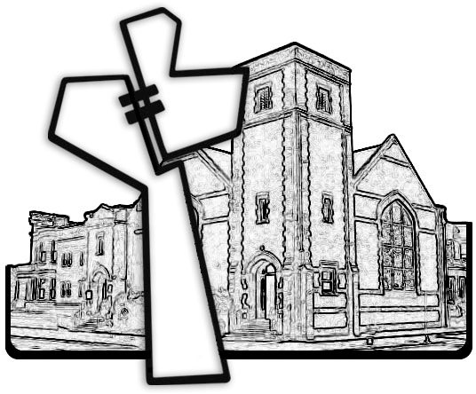



Chicago Community Mennonite Church

425 S. Central Park Blvd. (at Congress), Chicago, Illinois 60624-3224

www.ccmcil.org **|** facebook.com/ccmcil

**Church Council Chair:** Jason Gerig, 773-949-4496, jgerig@gmail.com

**Pastor:** Megan Ramer, 773-343-4251, pastor@ccmcil.org

Chicago Community Mennonite Church

September 14, 2014