Chicago Community Mennonite Church

August 3, 2014

Gathering

Prelude

Call to Worship

One: All you who are thirsty,

**All: this is a place for water.**

One: All you who are hungry,

**All: this is a place to be fed.**

One: Why spend your earnings on what is not food?

Why pay for that which fails to satisfy?

Here, without money,

here, without price,

**All: all may enjoy the bread of heaven.**

One: God speaks,

**All: and all who listen will have life.**

STJ 3 *Jesus calls us here to meet him*

Welcome

Lighting the Peace Lamp

Prayer

Praising

Psalm 145:8-9, 14-21

HWB 91 *Praise to God, immortal praise*

Children’s Time

STS 47 *Let the children come to me*

Receiving God’s Word

Isaiah 55:1-5

HWB 493 *I heard the voice of Jesus say*

Matthew 14:13-21

One: For the word of God in scripture,   
for the word of God among us,   
for the word of God within us,

**All: thanks be to God.**

Meditation

Responding

STJ 107 *God remembers*

Sharing

Prayer

Offering

HWB 76 *Je Louerai l’Eternel* *(Praise, I will praise you Lord)*

Sending

Announcements

STJ 112 *I owe my Lord a morning song*

Benediction

Extinguishing the Peace Candle

One: Now the light of Christ is in you.

**All: Thanks be to God.**

|  |
| --- |
| Worship Participants  Worship Leader: Beth Peachey  Meditation: Kiva Nice-Webb  Song Leader: Philip Kendall  Pianist: Steve Warkentin  Altar: Brooke Hutchison |

Announcements

**Pastor Megan’s Travel Schedule:** Pastor Megan is traveling to Colorado for an annual retreat with friends, mentors, and colleagues in the Rocky Mountains. She will be out of the office starting Wednesday July 30 and will be back at it Saturday August 9.

**Reception Following Karena’s Memorial Service:**  As a church, we are hosting a reception of finger foods for all who attend Karena's memorial service at Pilgrim Congregational in Oak Park on August 10. We are expecting up to 300 guests. Ross Bay is coordinating a team of volunteers to prepare and serve the food. Our expenses are just over $450. If you are able to contribute to the cost of food, gifts of all sizes will be most welcome: checks to CCMC with "memorial service" in the memo line. Thank you!

**Small Group Peace Study:** All are invited to join Michael and Barbara Sacco at their house one Sunday a month for a meal and bible study focused on peace and conflict resolution. We propose using the ‘Second Mile’ Menno Media small group bible study materials ‘peace journey for congregations’ that includes topics such as the spirituality of peace, the shadow of war, and transforming conflict. At our first meeting on Sunday, August 31, we will review the topics and decide together which one we’d like to focus on.. If you’d like to participate or need more information, please contact Michael or Barbara. mjsacco@att.net, bsacco63@yahoo.com

**Finishing Ian’s Quilt Today:** Ruby Campos will be bringing Ian Clark's graduation to fellowship time. All who wish to help put the finishing hand stitches on the binding are welcome to help out!

**Save the Date: September 27 at 2:00 p.m.:** Along with DOOR Chicago and North Suburban Mennonite Church, we at CCMC are hosting Ted Swartz's newest show, Listening for Grace. The 70-min. performance will be held in our sanctuary and followed by a talk back. In this show, Ted Swartz uses his distinctive humor to give voice to our fears and hopes when a faith community engages in questions around sexuality and same-sex relationships. It’s about a father’s journey, a church’s struggle and a search for commonality.

Schedule

|  |  |  |
| --- | --- | --- |
|  | **Today** | **Next Sunday** |
| **Greeter:** | Merle Baker | Katie VanderHeidi |
| **Nursery:** | Liz Finch  Phil Cordes | Hannah Klaassen  Steve Jost |
| **Fellowship:** | Jason Gerig | Joanne Zimmerly |

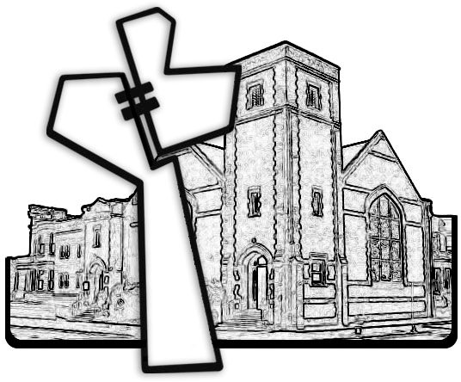



Chicago Community Mennonite Church

425 S. Central Park Blvd. (at Congress), Chicago, Illinois 60624-3224

www.ccmcil.org **|** facebook.com/ccmcil

**Church Council Chair:** Jason Gerig, 773-949-4496, jgerig@gmail.com

**Pastor:** Megan Ramer, 773-343-4251, pastor@ccmcil.org

Chicago Community Mennonite Church

August 3, 2014