Chicago Community Mennonite Church

August 31, 2014 ✢ Proper 17

Gathering

Prelude

Call to Worship

One: Come, Holy Spirit,

Lamplighter, midwife of change,

Comforter, disturber, inspirer, and advocate.

**All: Come, fill the church**

**with the gifts earth**

**can neither produce or afford.**

One: Come, fill our lives

with that rich mixture of peace and restlessness,

calm and enthusiasm,

which are hallmarks of holiness.

**All: Come, promised Spirit of God,**

**find your way and make your home among us. Amen**

Welcome

HWB 369 *Lord, whose love in humble service*

Praying

Lighting the Peace Lamp

Prayer for Peace

HWB 142 *Brothers and sisters of mine*

Psalm 105:1-6, 23-26, 45c

Children’s Time

*Let the children come to me; let the children come. Never hinder them; never stop them. O let the children come.*

HWB 621 *Jesus, friend so kind and gentle*

Receiving God’s Word

Exodus 3:1-15

Matthew 16:21-28

One: For the word of God in scripture,   
for the word of God among us,   
for the word of God within us,

**All: thanks be to God.**

Meditation

Responding

STS 115 *Beauty for brokenness*

Sharing

Prayer

Offering

Sending

Announcements

STS 124 *My soul cries out*

Benediction

Extinguishing the Peace Candle

**One: Now the light of Christ is in you.**

All: Thanks be to God.

|  |
| --- |
| Worship Participants  Worship Leader: Megan Ramer  Meditation: Rachael Weasley  Song Leader: Mariell Waltner  Pianist: Maria Paff |

Announcements

**Save the date:** Mark your calendars now for our second annual "Wine Down" event with DOOR Chicago, Thurs Oct 9, 6-9pm, at Inspiration Kitchens in East Garfield Park. Plan for an evening of good food & wine, great conversation, and both new & old friends. All proceeds will benefit the local youth participating and developing leadership capacities in our program. Invest in our youth, invest in our city. ~Pastor Megan, co-chair of the DOOR Chicago board

**Apple Party:** Apple picking & potluck in Michigan will be Saturday October 11. Mark your calendars now. More details to come.

**Ted & Co., *Listening for Grace*, September 27, 2:00 p.m.:** We are hosting Ted Swartz's newest show. The performance will be held in our sanctuary and followed by a talk back. Ted uses his distinctive humor to give voice to our fears and hopes when a faith community engages in questions around sexuality. It’s about a father’s journey, a church’s struggle and a search for commonality.

**Small Group Peace Study:** All are invited to join Michael and Barbara Sacco at their house one Sunday a month for a meal and bible study focused on peace and conflict resolution. We propose using the ‘Second Mile’ Menno Media small group bible study materials ‘peace journey for congregations’ that includes topics such as the spirituality of peace, the shadow of war, and transforming conflict. At our first meeting on **Sunday, September 14**, we will review the topics and decide together which one we’d like to focus on.. If you’d like to participate or need more information, please contact Michael or Barbara. mjsacco@att.net, bsacco63@yahoo.com

**Christian Peacemaker Teams Prayer for Peacemakers:** Pray for the stipended CPTers attending their biennial retreat this week in Quito, Ecuador, where they are learning about trauma and self care.  Pray also for the small teams of reservists and other CPTers who are staffing projects in Iraqi Kurdistan and Colombia so that stipended CPTers can attend retreat and for the work of CPT partners in Aboriginal communities, Colombia, Iraqi Kurdistan, and Palestine who continue the nonviolent struggles for justice and peace in their homelands.

Schedule

|  |  |  |
| --- | --- | --- |
|  | **Today** | **Next Sunday** |
| **Greeter:** | Kurt Frymire  Rosalynn Gingerich | Liz Finch |
| **Nursery:** | Tim Schuler  Antonia Kam | Rochelle Martin-Klaassen  Josiah Groff |
| **Fellowship:** | Spencer Foon  Geoff Martin |  |

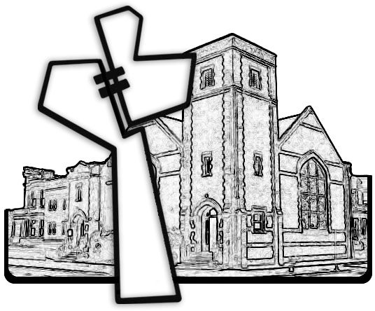



Chicago Community Mennonite Church

425 S. Central Park Blvd. (at Congress), Chicago, Illinois 60624-3224

www.ccmcil.org **|** facebook.com/ccmcil

**Church Council Chair:** Jason Gerig, 773-949-4496, jgerig@gmail.com

**Pastor:** Megan Ramer, 773-343-4251, pastor@ccmcil.org

Chicago Community Mennonite Church

August 31, 2014