Chicago Community Mennonite Church

August 24, 2014

Gathering

Prelude

Call to Worship

One: It is good to give thanks to the Lord,

**All: to sing praises to your name, O Most High;**

One: to declare your steadfast love in the morning,

**All: and your faithfulness by night.**

One: Let us worship God.

Welcome

STJ 4 *You’ve got a place*

Lighting the Peace Lamp

Prayer for Peace

Praising

HWB 285 *All hail the power of Jesus’ name* (vv. 1,2,4)

Psalm 138

Children’s Time (STS 47)

*Let the children come to me; let the children come.*

*Never hinder them; never stop them. O let the children come.*

Receiving God’s Word

Romans 12:1-8

STJ 72 *One is the body*

Matthew 16:13-20

One: For the word of God in scripture,   
for the word of God among us,   
for the word of God within us,

**All: thanks be to God.**

Meditation

Responding

HWB 472 *I am the Bread of life*

Sharing

Communion

Sending

Announcements

HWB 306 *In Christ there is no East or West*

Benediction

One: We go into the world as ambassadors of your love.

**All: We will be transformed by the renewing of our minds.**

One: We will not think more highly of ourselves than we ought.

**All: We will go to remember we can’t do it alone.**

One: Our God joins us together.

**All: Our God is a good God.**

Extinguishing the Peace Candle

**One: Now the light of Christ is in you.**

All: Thanks be to God.

|  |
| --- |
| Worship Participants  Worship Leader: Ross Bay  Meditation: Megan Ramer  Song Leader: Nancy Hostetter  Pianist: Steve Warkentin  Altar: Janet Friesen |

Announcements

**Collection for Migrant Children:** PJS and Worship committees are partnering to focus on the plight of unaccompanied migrant children in Chicago during our worship **Sunday August 31**. We are collecting stuffed animals, stickers, colored paper, glue, foam “noodles” (as used in swimming pools) and other art supplies for local kids. Donations will be delivered to the Chicago Religious Leadership Network. Please bring your donations by Sunday August 31.

**Small Group Peace Study, Today, 3pm:** All are invited to join Michael and Barbara Sacco at their house (6813 W Shakespeare Ave Chicago) for the first monthly gathering. If you’d like to participate or need more information, please contact Michael or Barbara. mjsacco@att.net, bsacco63@yahoo.com, or call (773) 804-1959.

**Karena Mendoza Memorial Service Programs:** If you were not able to be present for Karena's memorial service, extra programs can be found in the church library in a basket near the mailboxes. You are welcome to take one as a keepsake.

**Save the Date: September 27 at 2:00 p.m.:** Along with DOOR Chicago and North Suburban Mennonite Church, we at CCMC are hosting Ted Swartz's newest show, *Listening for Grace*. The 70-min. performance will be held in our sanctuary and followed by a talk back. In this show, Ted Swartz uses his distinctive humor to give voice to our fears and hopes when a faith community engages in questions around sexuality and same-sex relationships. It’s about a father’s journey, a church’s struggle and a search for commonality.

**Christian Peacemaker Teams Prayer for Peacemakers:** Pray for migrant and refugee children who come to Greece without their parents. Even if they have a family member with them, the authorities separate them if that family member is not a parent. Last week, volunteers working on the Mediterranean Project that CPT Europe supports spoke with a 12-13 year old Afghan boy who was crying because the authorities were going to hold him for a longer period by himself in the Moria Detention Center, even though he had been traveling with an aunt.

Schedule

|  |  |  |
| --- | --- | --- |
|  | **Today** | **Next Sunday** |
| **Greeter:** | Katie Vanderheide | Kurt Frymire  Rosalynn Gingerich |
| **Nursery:** | Brooke Hutchison  Brian Paff | Tim Schuler  Antonia Kam |
| **Fellowship:** | Katie Vanderheide | Spencer Foon  Geoff Martin |

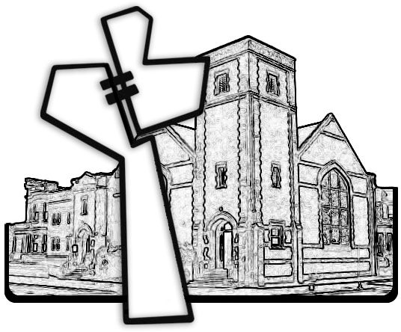



Chicago Community Mennonite Church

425 S. Central Park Blvd. (at Congress), Chicago, Illinois 60624-3224

www.ccmcil.org **|** facebook.com/ccmcil

**Church Council Chair:** Jason Gerig, 773-949-4496, jgerig@gmail.com

**Pastor:** Megan Ramer, 773-343-4251, pastor@ccmcil.org

Chicago Community Mennonite Church

August 24, 2014