Chicago Community Mennonite Church

August 17, 2014

Gathering

Prelude

Call to Worship

One: Christ our teacher, you reach into our lives not through instruction, but story.

**All: Open our hearts to be attentive:**

**that seeing, we may perceive,**

**and hearing, we may understand,**

**and understanding, we may act upon your word,**

**and in your name. Amen.**

Welcome

Lighting the Peace Lamp

Prayer

Praising

HWB 59 *Sing praise to God who reigns*

Children’s Time

STS 47 *Let the children come to me*

Recognition of James Peters-Fransen: graduation from nursery

Receiving God’s Word

Isaiah 56:1-8

Matthew 15:10-28

One: For the word of God in scripture,   
for the word of God among us,   
for the word of God within us,

**All: thanks be to God.**

HWB 310 *How good a thing it is*

Meditation

Responding

HWB 377 *Healer of our every ill*

Offering

Sharing

Prayer

Sending

Announcements

HWB 307 *Will you let me be your servant*

Extinguishing the Peace Candle

One: Now the light of Christ is in you.

**All: Thanks be to God.**

|  |
| --- |
| Worship Participants  Worship Leader: Mark Liechty  Meditation: Megan Ramer  Song Leader: Maria Paff  Pianist: Antonia Kam  Altar: Jody Schmidt |

Announcements

**Return of the CCMC Beer Group: Today!**

*When: Sunday, August 17 (today)

*Where: Martin & Liz Dyrst’s home in Logan Square

*When: 6:00 p.m.

*Bring: your favorite IPA and a beer snack

*Provided: black bean veggie chili (via Zemir and Chris)

*Theme: Resurrection

**Karena Mendoza Memorial Service Programs:** If you were not able to be present for Karena’s memorial service, extra programs can be found in the church library basket near the mailboxes. You are welcome to take one as a keepsake.

**Save the Date: September 27 at 2:00 p.m.:** Along with DOOR Chicago and North Suburban Mennonite Church, we at CCMC are hosting Ted Swartz's newest show, *Listening for Grace*. The 70-min. performance will be held in our sanctuary and followed by a talk back. In this show, Ted Swartz uses his distinctive humor to give voice to our fears and hopes when a faith community engages in questions around sexuality and same-sex relationships. It’s about a father’s journey, a church’s struggle and a search for commonality.

**Small Group Peace Study:** All are invited to join Michael and Barbara Sacco at their house one Sunday a month for a meal and bible study focused on peace and conflict resolution. We propose using the ‘Second Mile’ Menno Media small group bible study materials ‘peace journey for congregations’ that includes topics such as the spirituality of peace, the shadow of war, and transforming conflict. At our first meeting on **Sunday, August 31**, we will review the topics and decide together which one we’d like to focus on.. If you’d like to participate or need more information, please contact Michael or Barbara. mjsacco@att.net, bsacco63@yahoo.com

**Christian Peacemaker Teams Prayer for Peacemakers:** Pray that the heart of  Leonel Gutierrez Lagares, Inspector of Police of Vijagual, who has tried to evict the community of El Guayabo five times from its land, will be moved to repentance by CPT Colombia’s petition to him protesting a violent 26 June 2014 eviction.  Ask that God continue to encourage the hearts of the people of El Guayabo as they nonviolently resist systemic powers trying to move them out of the way.

Schedule

|  |  |  |
| --- | --- | --- |
|  | **Today** | **Next Sunday** |
| **Greeter:** | Jason Gerig | Katie Vanderheide |
| **Nursery:** | Bob Hostetter  Mark Frey | Brooke Hutchison  Brian Paff |
| **Fellowship:** | Rosalynn Gingerich | Katie Vanderheide |

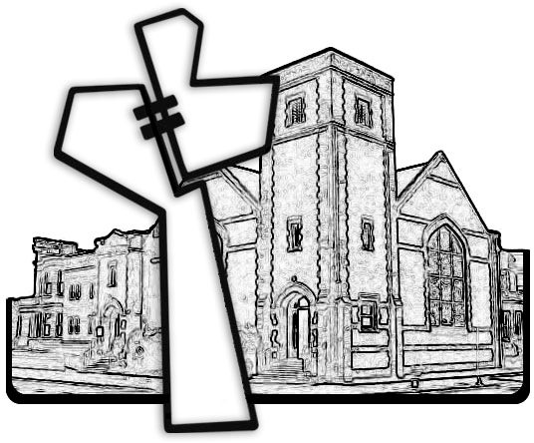



Chicago Community Mennonite Church

425 S. Central Park Blvd. (at Congress), Chicago, Illinois 60624-3224

www.ccmcil.org **|** facebook.com/ccmcil

**Church Council Chair:** Jason Gerig, 773-949-4496, jgerig@gmail.com

**Pastor:** Megan Ramer, 773-343-4251, pastor@ccmcil.org

Chicago Community Mennonite Church

August 17, 2014