Chicago Community Mennonite Church

August 10, 2014

Gathering

Prelude

Call to Worship

One: Christ is risen!

**All: Christ is risen indeed!**

One: The grace of our Lord Jesus Christ,

the love of God,

and the communion of the Holy Spirit be with you all.

**All: And also with you.**

One: We gather this morning as we live:

as God’s beloved people.

Let us welcome and celebrate God’s new day

**All: Amen.**

Welcome

Lighting the Peace Lamp

Prayer

Praising

HWB 580 *My life flows on*

Presentation of Quilt to Ian Clark

Children’s Time

STS 47 *Let the children come to me*

Receiving God’s Word

Psalm 85:8-13

HWB 446 *Wade in the water*

Matthew 14:22-33

One: For the word of God in scripture,   
for the word of God among us,   
for the word of God within us,

**All: thanks be to God.**

Meditation

Responding

STJ 65 *Let justice flow like streams*

Offering

HWB 226 *You are the salt for the earth*

Prayer

Archeology of Our Faith

One: Surely the Lord would say of Lina Zook Ressler,

**All: Well done thou good and faithful servant.**

Sharing

MVS Blessing

Prayer

Sending

Announcements

STJ 73 *The Lord lift you up*

Extinguishing the Peace Candle

One: Now the light of Christ is in you.

**All: Thanks be to God.**

|  |
| --- |
| Worship Participants  Worship Leader: Celeste Grace Groff  Meditation: Joanna Shenk  Song Leader: Glenn Martin Klaassen  Pianist: Beth Peachey  Altar: Antonia Kam |

Announcements

**Memorial Service for Karena Mendoza, Today, 3:00 p.m.:** We will gather for a service of remembrance this afternoon at Pilgrim Congregational Church, 460 Lake Street, Oak Park IL. **Reception:**  As a church, we are hosting a reception of finger foods for all who attend Karena's memorial service. Our expenses are just over $450. If you are able to contribute to the cost of food, gifts of all sizes are welcome: checks to CCMC with "memorial service" in the memo line. Thank you!

**Save the Date: September 27 at 2:00 p.m.:** Along with DOOR Chicago and North Suburban Mennonite Church, we at CCMC are hosting Ted Swartz's newest show, Listening for Grace. The 70-min. performance will be held in our sanctuary and followed by a talk back. In this show, Ted Swartz uses his distinctive humor to give voice to our fears and hopes when a faith community engages in questions around sexuality and same-sex relationships. It’s about a father’s journey, a church’s struggle and a search for commonality.

**Small Group Peace Study:** All are invited to join Michael and Barbara Sacco at their house one Sunday a month for a meal and bible study focused on peace and conflict resolution. We propose using the ‘Second Mile’ Menno Media small group bible study materials ‘peace journey for congregations’ that includes topics such as the spirituality of peace, the shadow of war, and transforming conflict. At our first meeting on Sunday, August 31, we will review the topics and decide together which one we’d like to focus on.. If you’d like to participate or need more information, please contact Michael or Barbara. mjsacco@att.net, bsacco63@yahoo.com

**Christian Peacemaker Teams Prayer for Peacemakers:** Pray that the heart of  Leonel Gutierrez Lagares, Inspector of Police of Vijagual, who has tried to evict the community of El Guayabo five times from its land, will be moved to repentance when CPT Colombia delivers a petition to him this week protesting a violent 26 June 2014 eviction.  Ask that God continue to encourage the hearts of the people of El Guayabo as they nonviolently resist systemic powers trying to move them out of the way.

Schedule

|  |  |  |
| --- | --- | --- |
|  | **Today** | **Next Sunday** |
| **Greeter:** | Josiah Groff | Kate Myers |
| **Nursery:** | Russell Johnson  Steve Jost | Bob Hostetter  Mark Frey |
| **Fellowship:** | Joanne Zimmerly | Rosalynn Gingerich |

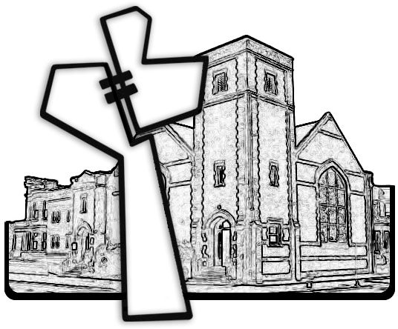



Chicago Community Mennonite Church

425 S. Central Park Blvd. (at Congress), Chicago, Illinois 60624-3224

www.ccmcil.org **|** facebook.com/ccmcil

**Church Council Chair:** Jason Gerig, 773-949-4496, jgerig@gmail.com

**Pastor:** Megan Ramer, 773-343-4251, pastor@ccmcil.org

Chicago Community Mennonite Church

August 10, 2014