Chicago Community Mennonite Church

July 6, 2014

Gathering

Prelude

Call to Worship

One: God of all creation,

**All: What do you require of us?**

One: To do justice,

**All: seeking peace and reconciliation,**

**standing with the marginalized and forgotten**

One: to love kindness,

**All: showing compassion and unconditional caring**

**for those in need,**

One: to walk humbly,

**All: following in the steps of Jesus,**

**lifting up not the work of our hands**

**but the power that sustains our service.**

STS 115 *Beauty for brokenness*

Welcome

STJ 32 *If you believe and I believe*

STJ 2 *Hamba nathi (Come, walk with us)*

Lighting the Peace Lamp

Prayer

Praising

STS 47 *Let the children come to me*

Children’s Time

HWB 580 *My life flows on*

Receiving God’s Word

Zachariah 9:9-12

Matthew 11:16-19, 25-30

Psalm 145:8-14

One: For the word of God in scripture,   
for the word of God among us,   
for the word of God within us,

**All: thanks be to God.**

Meditation

Responding

Offering

Sharing

Prayer

Sending

STJ 110  *Go, silent friend*

Announcements

STJ 4 *You’ve got a place*

Benediction

Extinguishing the Peace Candle

**One: Now the light of Christ is in you.**

All: Thanks be to God.

|  |
| --- |
| Worship Participants  Worship Leader: Benjamin Anderson  Meditation: Megan Ramer  Song Leader: Philip Kendall  Pianist: Kiva Nice-Webb  Altar: Brooke Hutchison |

Announcements

**Worship Leader Training Sunday, July 20, 11 a.m.**: Are you interested in leading worship? Or, have you done it before but still want some pointers? Then join us for an orientation after fellowship time on Sunday, July 20. We'll guide you through the worship leader resources, explain updates on the church website, and give plenty of opportunity for questions and discussion. For anyone who loves leading worship, or is interested in trying it out, this will be a great chance to find your footing or refresh your memory. Everyone welcome!

**Save the Date for Dunes Sunday, July 27:** We will gather at the Indiana Dunes State Park for worship at 10:30 a.m. (Chicago time), with a potluck picnic to follow. There *will not* be a worship service in Chicago that morning. More info to come!

**Christian Peacemaker Teams Prayer for Peacemakers:** Pray that now that Colombians have re-elected Juan Manuel Santos, he will follow through, via negotiations with the FARC and ELN guerilla groups, on his commitment to end the decades-long civil war in Colombia.

Schedule

|  |  |  |
| --- | --- | --- |
|  | **Today** | **Next Sunday** |
| **Greeter:** | Mariell Waltner | Jan Lugibihl |
| **Nursery:** | Steve Warketin  Sara Reschley | Mark Liechty  Kiva Nice-Webb |
| **Fellowship:** | Spencer Foon | Rochelle Martin Klaassen |

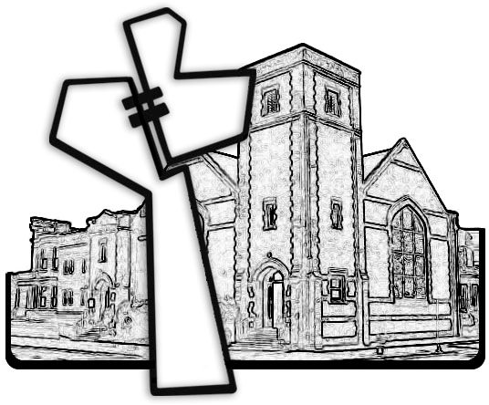



Chicago Community Mennonite Church

425 S. Central Park Blvd. (at Congress), Chicago, Illinois 60624-3224

www.ccmcil.org **|** facebook.com/ccmcil

**Church Council Chair:** Jason Gerig, 773-949-4496, jgerig@gmail.com

**Pastor:** Megan Ramer, 773-343-4251, pastor@ccmcil.org

Chicago Community Mennonite Church

July 6, 2014