Chicago Community Mennonite Church

July 20, 2014

Gathering

Prelude

Call to Worship

One: Wait! Watch!

The Day of God is at hand!

**Many: Like the bud on a tree, God’s possibilities are about to blossom.**

One: Stay awake!

The reign of God is very near!

**Many: We are here.**

**Watching and waiting with hope.**

**All: May God bring justice to all people on this day.**

**May God’s reign come on earth as it is in heaven.**

HWB 37 *Praise to the Lord, the Almighty*

Welcome

Lighting the Peace Lamp

Prayer

Praising

Psalm 139:1-12, 23-24

HWB 556 *Lord, thou hast searched me*

Children’s Time: STS 47 *Let the children come to me*

Receiving God’s Word

Romans 18:12-25

HWB 530 *What wondrous love is this*

Matthew 13:24-43

One: For the word of God in scripture,   
for the word of God among us,   
for the word of God within us,

**All: thanks be to God.**

Meditation

Responding

Offering

HWB 392 *Heart and mind, possessions, Lord*

Sharing

Prayer

Sending

Announcements

STS 115 *Beauty for brokenness*

Benediction

One: The blessing of God,

the shalom of God,

the wildness and warmth of God,

be among us and between us,

now and always.

**Many: The divine Spirit dwells in us**

**All: Thanks be to God.**

Extinguishing the Peace Candle

One: Now the light of Christ is in you.

**All: Thanks be to God.**

|  |
| --- |
| Worship Participants  Worship Leader: Linda Becker  Meditation: Megan Ramer  Song Leader: Dan Bertsche  Pianist: Antonia Kam  Altar: Jody Schmidt |

Announcements

**Worship Leader Training Today, 11 a.m.**: Are you interested in leading worship? Or, have you done it before but still want some pointers? Then join us for an orientation after fellowship time. We'll guide you through the worship leader resources, explain updates on the church website, and give plenty of opportunity for questions and discussion. Everyone welcome!

**Memorial Service for Karena Mendoza:** We will gather on Sunday, August 10, 3:00 p.m. at Pilgrim Congregational Church, 460 Lake St., Oak Park. Please stay tuned for ways you can contribute to our hosting this gathering for Karena’s many communities of friends and family.

**Dunes Sunday, July 27:** We will gather at the Indiana Dunes State Park for worship at 10:30 a.m. (Chicago time), with a potluck picnic to follow, and beach frivolity to follow that! There *will not* be a worship service in Chicago. Please bring:

* $10 entrance fee per car
* chairs and/or blankets to throw on the ground
* your own tableware
* a dish to share
* charcoal and grill-ables if you’d like—grill available at shelter
* your own beverages—drinking water available at shelter

**Christian Peacemaker Teams Prayer for Peacemakers:** Pray for the people of Grassy Narrows. The Supreme Court of Canada ruled this week that the Ontario government could permit industrial logging on their traditional lands immediately.

Schedule

|  |  |  |
| --- | --- | --- |
|  | **Today** | **Next Sunday** |
| **Greeter:** | Julia Rohan | Dunes Sunday |
| **Nursery:** | Kiva Nice-Webb  Laura Hostettler | Dunes Sunday |
| **Fellowship:** | Benjamin Anderson | Dunes Sunday |

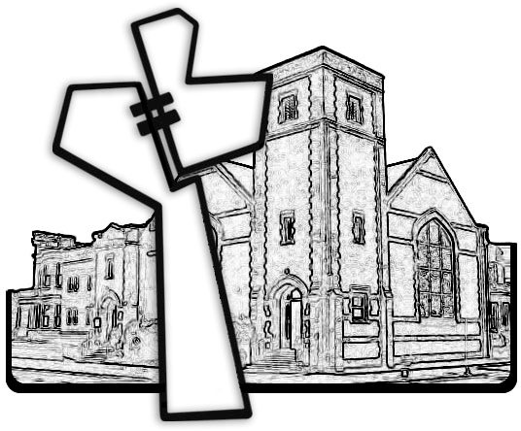



Chicago Community Mennonite Church

425 S. Central Park Blvd. (at Congress), Chicago, Illinois 60624-3224

www.ccmcil.org **|** facebook.com/ccmcil

**Church Council Chair:** Jason Gerig, 773-949-4496, jgerig@gmail.com

**Pastor:** Megan Ramer, 773-343-4251, pastor@ccmcil.org

Chicago Community Mennonite Church

July 20, 2014