Chicago Community Mennonite Church

July 13, 2014

Gathering

Prelude

Call to Worship

STJ 67 *Let there be light, Lord God*

Welcome

Lighting the Peace Lamp

Prayer

Praising

HWB 111 *O praise the gracious power*

STS 47 *Let the children come to me*

Children’s Time

Psalm 145:8-14

Receiving God’s Word

STJ 79 *As I went down to the river*

Zechariah 9:9-12

Matthew 11:16-19, 25-30

One: For the word of God in scripture,   
for the word of God among us,   
for the word of God within us,

**All: thanks be to God.**

Meditation

Responding

HWB 403 *The church of Christ in every age*

Archeology of our Faith

Sharing

Prayer

Offering

STJ 4 *You’ve got a place*

Sending

Announcements

HWB 421 *Bless’d be the ties that binds*

Extinguishing the Peace Candle

**One: Now the light of Christ is in you.**

All: Thanks be to God.

|  |
| --- |
| Worship Participants  Worship Leader: Kiva Nice-Webb  Meditation: Megan Ramer  Song Leader: Glenn Martin Klaassen  Pianist: Steve Warkentin  Altar: Brooke Hutchison |

Announcements

**Blueberries and Fellowship:** Saturday, July 19 is our annual blueberry picking trip to Rehoboth Mennonite Church & Camp. We will again join them for their annual blueberry festival. Schedule, directions, and more details can be found in the email sent to the listserv. If you didn’t receive that email or need it again, contact Pastor Megan.

**Pastor Megan’s travel schedule:** I am traveling July 14-16 to Columbus Ohio to speak for the “Ethics of Sex” class at Methodist Theological School of Ohio. I’ve been invited to speak about my own journey of becoming an advocate for LGBTQ justice in the church, and to discuss how ecclesial change can and does happen. I’ll be back in the office Wed-Thur, July 16-17.

**Worship Leader Training Sunday, July 20, 11 a.m.**: Are you interested in leading worship? Or, have you done it before but still want some pointers? Then join us for an orientation after fellowship time on Sunday, July 20. We’ll guide you through the worship leader resources, explain updates on the church website, and give plenty of opportunity for questions and discussion. For anyone who loves leading worship, or is interested in trying it out, this will be a great chance to find your footing or refresh your memory. Everyone welcome!

**Dunes Sunday, July 27:** We will gather at the Indiana Dunes State Park for worship at 10:30 a.m. (Chicago time), with a potluck picnic to follow. There *will not* be a worship service in Chicago that morning. More info to come!

**Quilt / Art Show:** Ruby Yoder Campos’s quilts will be featured in this show on July 19-20, from 1:00-4:00 p.m. at 10232 Wilson Road  
New Buffalo, Mich. All are invited.

**Christian Peacemaker Teams Prayer for Peacemakers:** Pray that now that Colombians have re-elected Juan Manuel Santos, he will follow through, via negotiations with the FARC and ELN guerilla groups, on his commitment to end the decades-long civil war in Colombia.

Schedule

|  |  |  |
| --- | --- | --- |
|  | **Today** | **Next Sunday** |
| **Greeter:** | Jan Lugibihl | Julia Rohan |
| **Nursery:** | Mark Liechty  Derek Becker | Kiva Nice-Webb  Laura Hostettler |
| **Fellowship:** | Rochelle Martin Klaassen | Benjamin Anderson |

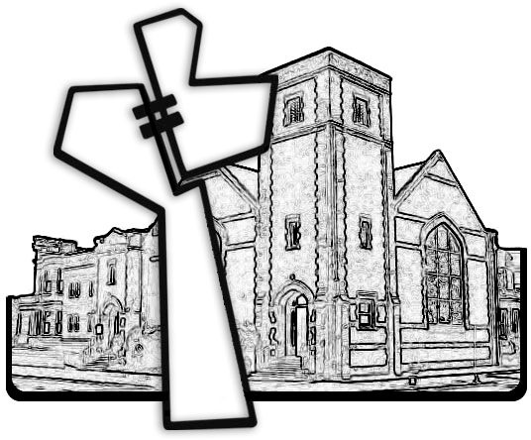



Chicago Community Mennonite Church

425 S. Central Park Blvd. (at Congress), Chicago, Illinois 60624-3224

www.ccmcil.org **|** facebook.com/ccmcil

**Church Council Chair:** Jason Gerig, 773-949-4496, jgerig@gmail.com

**Pastor:** Megan Ramer, 773-343-4251, pastor@ccmcil.org

Chicago Community Mennonite Church

July 13, 2014