Chicago Community Mennonite Church

June 8, 2014

Gathering

Prelude

Call to Worship

Welcome

STJ 56 *Make me a channel of your peace*

Lighting the Peace Lamp

Prayer

Praising

STJ 49 *Rain down*

HWB 356 *Breath on me, breath of God*

Children’s Time

Receiving God’s Word

John 20:19-21

Acts 2:1-11

One: For the word of God in scripture,   
for the word of God among us,   
for the word of God within us,

**All: thanks be to God.**

Meditation

Responding

STJ 61 *How can we be silent*

Archeology of Our Faith

Offering

Sharing

Prayer

Sending

Announcements

HWB 433 *Go, my children*

Benediction

Extinguishing the Peace Candle

**One: Now the light of Christ is in you.**

All: Thanks be to God.

|  |
| --- |
| Worship Participants  Worship Leaders: Justin Beeker and Erin Beeker  Meditation: Leah Kabira  Song Leader: Glen Martin Klaasen  Pianist: Beth Peachey  Altar: Antonia Kam |

Announcements

**Adult Education today:** The Education Committee will host a special Second Hour with parents and teachers to reflect on the 2013-2014 Sunday School year and to explore new ideas for the coming year. We are excited to come together as a community to talk about youth education at CCMC - all are welcome!

**CDC Family Day & Run/Walk/Bike-a-thon:** Central District Conference's annual meeting is scheduled for June 26-28 in Madison, WI. There are several ways you can be involved!

* Family Day (June 26): Whether you're a delegate to the CDC meeting or not, you're welcome for a picnic dinner, a worship service, and a bluegrass concert and ice cream social. More information can be found at centraldistrict.mennonite.net.
* Run-Walk-Bike-a-thon (June 26): at 1:00 P.M., all are invited to complete one of the following: a 5K run/walk, a 7 mile run, a 10.5 mile run, a 21 mile ride, or a 48 mile ride. Participants are asked to raise pledges of a suggested $100. But no one who wants to participate will be turned away. More info at <https://www.facebook.com/cdcrunwalkbikeathon>
* CDC Pledges: And on that note, I'm running the 10.5 mile route and am looking for pledges! If you'd like to make a pledge, you can bring a check written out to CDC on any of the next four Sundays. Any amount will be appreciated!

**Christian Peacemaker Teams Prayer for Peacemakers:** Pray for those participating in the refugee-led Freedom March to Brussels, a protest against the repressive and racist European migration regime.

Schedule

|  |  |  |
| --- | --- | --- |
|  | **Today** | **Next Sunday** |
| **Greeter:** | Derek Becker | Ross Bay |
| **Nursery:** | Kate Myers  Jane Baker | Janet Friesen  Allison Schuler |
| **Fellowship:** | Russell Johnson | Ross Bay |
| **Welcome Table:** | Spencer Foon  Mariell Waltner |  |

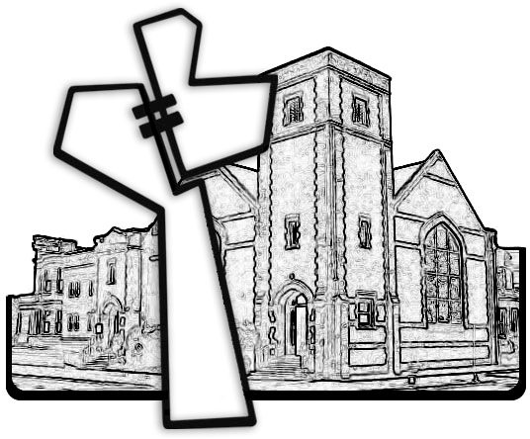



Chicago Community Mennonite Church

425 S. Central Park Blvd. (at Congress), Chicago, Illinois 60624-3224

www.ccmcil.org **|** facebook.com/ccmcil

**Church Council Chair:** Jason Gerig, 773-949-4496, jgerig@gmail.com

**Pastor:** Megan Ramer, 773-343-4251, pastor@ccmcil.org

Chicago Community Mennonite Church

June 8, 2014