Chicago Community Mennonite Church

June 29, 2014

Gathering

Prelude

Call to Worship

One: We are made in the image of God.

**All: We praise our God**

**and celebrate the diversity of all creation.**

One: It is written

that God declared all of creation to be good.

**All: All our goodness comes from our Divine Creator.**

One: Eye has not seen nor ear heard

the goodness of eccentricities of our God.

**All: We delight ourselves**

**in being created with such imagination**

One: You are called beautiful and fabulous

by the Holy Lover.

**All: In this love we bask and rejoice, declaring our love in return and giving ourselves wholly to you.**

Welcome

HWB 592 *Love divine, all loves excelling*

Lighting the Peace Lamp

Prayer

Praising

HWB 404 *O Jesus Christ, may grateful hymns*

Psalm 13

Children’s Time

Receiving God’s Word

Genesis 22:1-14

STS 82 *How long, O Lord*

Romans 11:33-36

Matthew 10:40-42

One: For the word of God in scripture,   
for the word of God among us,   
for the word of God within us,

**All: thanks be to God.**

Meditation

Responding

HWB 369 *Lord, whose love in humble service*

Sharing

Prayer

Offering

HWB 392 *Heart and mind, possessions, Lord*

Sending

Announcements

STS 40 *Som’landela (We will follow)*

Benediction

Extinguishing the Peace Candle

**One: Now the light of Christ is in you.**

All: Thanks be to God.

|  |
| --- |
| Worship Participants  Worship Leader: Justin Hochstetler  Meditation: Celeste Groff  Song Leader: Mariell Waltner  Pianist: Maria Paff  Altar: Megan Ramer |

Announcements

**Worship Leader Training, Sunday, June 20:** Are you interested in leading worship? Or, have you done it before but still want some pointers? Then join us for an orientation after fellowship time on Sunday, July 20. We’ll guide you through the worship leader resources, explain updates on the church website, and give plenty of opportunity for questions and discussion. For anyone who loves leading worship, or is interested in trying it out, this will be a great chance to find your footing or refresh your memory. Everyone welcome!

**Save the Date for Dunes Sunday, July 27:** We will gather at the Indiana Dunes State Park for worship at 10:30 a.m. (Chicago time), with a potluck picnic to follow. There *will not* be a worship service in Chicago that morning. More info to come!

**Christian Peacemaker Teams Prayer for Peacemakers:** Pray that now that Colombians have re-elected Juan Manuel Santos, he will follow through, via negotiations with the FARC and ELN guerilla groups, on his commitment to end the decades-long civil war in Colombia.

Schedule

|  |  |  |
| --- | --- | --- |
|  | **Today** | **Next Sunday** |
| **Greeter:** | Hannah Klaassen | Mariell Waltner |
| **Nursery:** | Sherry Jost  Naomi Liechty | Steve Warketin  Sara Reschley |
| **Fellowship:** | Jan Lugibihl | Sherry Jost |

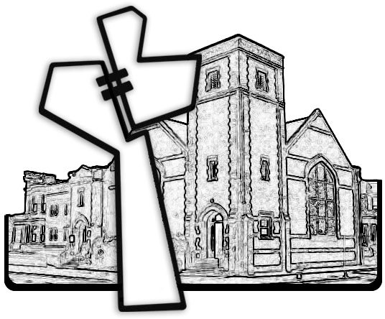



Chicago Community Mennonite Church

425 S. Central Park Blvd. (at Congress), Chicago, Illinois 60624-3224

www.ccmcil.org **|** facebook.com/ccmcil

**Church Council Chair:** Jason Gerig, 773-949-4496, jgerig@gmail.com

**Pastor:** Megan Ramer, 773-343-4251, pastor@ccmcil.org

Chicago Community Mennonite Church

June 29, 2014