Chicago Community Mennonite Church

June 22, 2014

Gathering

Prelude

Call to Worship

One: All you who are thirsty

**All: this is the place for water.**

One: All you who are hungry,

**All: this is the place to be fed.**

One: Why spend your earnings on what is not food?

**All: Why pay for that which fails to satisfy?**

One: Here, without money,

**All: Here, without price,**

One: all may enjoy the bread of heaven.

God speaks,

**All: and all who listen will have life.**

Welcome

HWB 6 *Here in this place*

Lighting the Peace Lamp

Prayer

Praising

HWB 29 *Like the murmur of the dove’s song*

Psalm 86

Children’s Time

Nursery Graduation for August Franklin

Receiving God’s Word

STS 11 No wind at the window

Matthew 10:24-39

One: For the word of God in scripture,   
for the word of God among us,   
for the word of God within us,

**All: thanks be to God.**

Meditation

Responding

HWB 357 *O Master, let me walk with thee*

Offering

Sharing

Communion

Prayer

HWB 356 *Breathe on me, breath of God*

Sending

Announcements

STS 11 *No wind at the window*

Benediction

Extinguishing the Peace Candle

**One: Now the light of Christ is in you.**

All: Thanks be to God.

|  |
| --- |
| Worship Participants  Worship Leader: Rachael Weasley  Meditation: Megan Ramer  Song Leader: Nancy Hostetter  Pianist: Steve Warkentin  Altar: Janet Friesen |

Announcements

**CDC Family Day & Run/Walk/Bike-a-thon:** Central District Conference's annual meeting is scheduled for June 26-28 in Madison, WI. There are several ways you can be involved!

* Family Day (June 26): Whether you're a delegate to the CDC meeting or not, you're welcome for a picnic dinner, a worship service, and a bluegrass concert and ice cream social. More information can be found at centraldistrict.mennonite.net.
* Run-Walk-Bike-a-thon (June 26): at 1:00 P.M., all are invited to complete one of the following: a 5K run/walk, a 7 mile run, a 10.5 mile run, a 21 mile ride, or a 48 mile ride. More info at <https://www.facebook.com/cdcrunwalkbikeathon>
* CDC Pledges: If you'd like to make a pledge, you can give Jason Gerig or Pastor Megan a check written out to CDC. Any amount will be appreciated and put to good use!

**Save the Date for Dunes Sunday—July 27:** We will gather at the Indiana Dunes State Park for worship at 10:30 a.m. (Chicago time), with a potluck picnic to follow. There *will not* be a worship service in Chicago that morning. More info to come!

**Christian Peacemaker Teams Prayer for Peacemakers:** The Iraqi Kurdistan team writes, “As violent struggles continue for control of key Iraqi cities, Kurdistan focuses on power and security. With the conflict unfolding, and our work with partners locked in land struggles with oil companies continuing, your support and prayers are appreciated for our team and for peace for the Iraqi and Kurdish people.”

Schedule

|  |  |  |
| --- | --- | --- |
|  | **Today** | **Next Sunday** |
| **Greeter:** | Derek Becker | Mariell Waltner |
| **Nursery:** | Russell Johnson  Sean Connor | Celeste Groff  Sherry Jost |
| **Fellowship:** | Kate Myers | Jan Lugibihl |

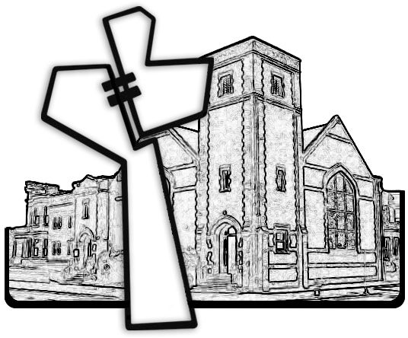



Chicago Community Mennonite Church

425 S. Central Park Blvd. (at Congress), Chicago, Illinois 60624-3224

www.ccmcil.org **|** facebook.com/ccmcil

**Church Council Chair:** Jason Gerig, 773-949-4496, jgerig@gmail.com

**Pastor:** Megan Ramer, 773-343-4251, pastor@ccmcil.org

Chicago Community Mennonite Church

June 22, 2014