Chicago Community Mennonite Church

June 1, 2014

Gathering

Prelude

Call to Worship

One: We shout for joy to God who rides upon the clouds!

**All: We sing praises to our awe-inspiring God,   
before whom the earth quakes,  
and whose abundant blessings   
provide for all in need!**

One: God is Sovereign over the earth,   
Defender of the defenseless, and Parent to orphans;   
God creates families for those who are alone.

**All: God leads captives to freedom   
and breaks the yoke of oppression.**

One: God goes forth before the people,   
marching through the wilderness of their lives,   
bringing forth restoration and justice.

**All: Sing praise to God, Rider of the ancient skies,   
who dwells in holiness.**

One: Proclaim the power of God!

**All: O God, how awesome you are in your sanctuary!   
You give power and strength to your people.**

One: Let us worship God!

Welcome

HWB 26 *Holy Spirit, come with power*

Lighting the Peace Lamp

Prayer

Praising

HWB 59 *Sing praise to God who reigns*

Children’s Time

Receiving God’s Word

Luke 24:44-53

HWB 285 *All hail the power of Jesus’ name*

Acts 2:42-47

One: For the word of God in scripture,   
for the word of God among us,   
for the word of God within us,

**All: thanks be to God.**

Meditation

Responding

HWB 306 *In Christ there is no East or West*

Sharing

Prayer

Offering: HWB 383 *God, whose giving*

Sending

Announcements

HWB 420 *Heart with loving heart united*

Benediction

Extinguishing the Peace Candle

**One: Now the light of Christ is in you.**

All: Thanks be to God.

|  |
| --- |
| Worship Participants  Worship Leaders: Ross Bay  Meditation: Krista Dutt  Song Leader: Philip Kendall  Pianist: Kiva Nice-Webb  Altar: Brooke Hutchison |

Announcements

**Church Picnic today:** CCMC will have our Annual Picnic today after church. This is an opportunity to thank Sunday School Teachers and spend a lovely afternoon in Garfield Park. Bring your own plate, silverware, blanket or chair and a dish to share. The Fellowship Committee will provide ice, water, lemonade and cups. If it rains, we will have our picnic inside the church.

**Christian Peacemaker Teams Prayer for Peacemakers:** Pray that Supreme Court of Canada will render a just decision, now that it has finished hearing the case presented by the Grassy Narrows’ Trappers that they have rights guaranteed by Treaty and Higher Authority to use their traditional lands.

**Pastor Megan on Sabbatical:** Megan is on sabbatical and will be unavailable until her return on Sunday, June 8. If you are in need of pastoral care in her absence, please contact Celeste Groff (312-505-9791), or a member of our Pastoral Care Team: Ross Bay (773-329-3872), Derek Becker (773-354-8553), Nancy Hostetter (773-784-7457), Jan Lugibihl (312-307-1674). More info can be found in the sabbatical packets available in our library, just behind the sanctuary.

Schedule

|  |  |  |
| --- | --- | --- |
|  | **Today** | **Next Sunday** |
| **Greeter:** | Russell Johnson | Brooke Hutchison |
| **Nursery:** | Cecilia Goertzen  Janet Friesen | Kate Meyers  Jane Baker |
| **Fellowship:** | Annual Picnic | Russell Johnson |
| **Welcome Table:** | Annual Picnic | Spencer Foon  Mariell Waltner |

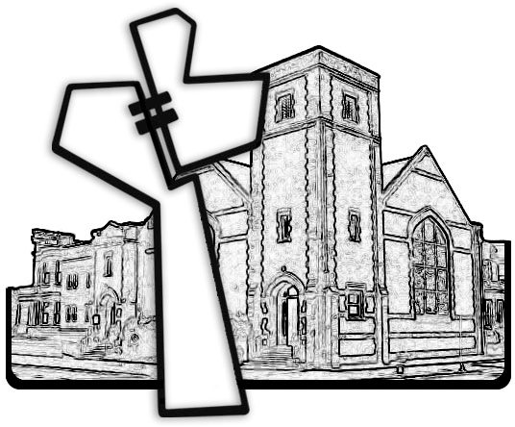



Chicago Community Mennonite Church

425 S. Central Park Blvd. (at Congress), Chicago, Illinois 60624-3224

www.ccmcil.org **|** facebook.com/ccmcil

**Church Council Chair:** Jason Gerig, 773-949-4496, jgerig@gmail.com

**Pastor:** Megan Ramer, 773-343-4251, pastor@ccmcil.org

Chicago Community Mennonite Church

June 1, 2014