Chicago Community Mennonite Church

June 15, 2014

Gathering

Prelude

Call to Worship

One: Praise to God our Creator, Mother of all and wellspring of life.

**All: Praise to God our liberator,**

**who sets us free and gives us hope.**

One: Praise to God the Word,

love made flesh to dwell among us

**All: Praise to Jesus the Christ, who feeds the hungry and shows us the Way.**

One: Praise to God the Spirit, fiery light and rushing wind.

**All: Praise to the Holy Spirit, she inspires, challenges, comforts, and sustains us.**

One: Come let us worship the Earth-maker, the Pain-bearer, and the Life-giver.

**All: Let us worship God!**

HWB 154 *This is my Father’s world*

Welcome

Lighting the Peace Lamp

Prayer

One: At times we turn away from the poverty we see,

from the jingle of change in cups,

**All: God, have mercy.**

One: At times we have no tears when another youth is shot,

**All: God, have mercy.**

One: At times we long for an open field and clear brook, instead of pavement and tall buildings.

**All: God, have mercy.**

One: At times we long for silence,

as the sirens ring and trains clatter

**All: God, have mercy.**

One: Grant us all we need to seek the peace of this city,

Oh God

**All: Amen.**

Praising

STS 119 *We believe, as one by one*

Bible Presentation to Isaiah Carter

Children’s Time

Psalm 8

*Psalms for Prayer: An Invitation to Wholeness* Nan C. Merrill

STJ 33 *Come, Holy Spirit, descend*

Receiving God’s Word

Matthew 28:16-20

Genesis 1:1-2:4a

One: For the word of God in scripture,   
for the word of God among us,   
for the word of God within us,

**All: thanks be to God.**

Meditation

Responding

Offering

STJ 34 *Loving Spirit*

Sharing

Sending of the Carter Family

Prayer

Sending

STS 57 *Go, my friends, in grace*

Announcements

Benediction

Extinguishing the Peace Candle

**One: Now the light of Christ is in you.**

All: Thanks be to God.

|  |
| --- |
| Worship Participants  Worship Leader: Benjamin Anderson  Meditation: Megan Ramer  Song Leader: Maria Paff  Pianist: Kiva Nice-Webb  Altar: Jody Schmidt |

Announcements

**CDC Family Day & Run/Walk/Bike-a-thon:** Central District Conference's annual meeting is scheduled for June 26-28 in Madison, WI. There are several ways you can be involved!

* Family Day (June 26): Whether you're a delegate to the CDC meeting or not, you're welcome for a picnic dinner, a worship service, and a bluegrass concert and ice cream social. More information can be found at centraldistrict.mennonite.net.
* Run-Walk-Bike-a-thon (June 26): at 1:00 P.M., all are invited to complete one of the following: a 5K run/walk, a 7 mile run, a 10.5 mile run, a 21 mile ride, or a 48 mile ride. Participants are asked to raise pledges of a suggested $100. But no one who wants to participate will be turned away. More info at <https://www.facebook.com/cdcrunwalkbikeathon>
* CDC Pledges: If you'd like to make a pledge, you can bring a check written out to CDC on any of the next four Sundays. Any amount will be appreciated!

**Christian Peacemaker Teams Prayer for Peacemakers:** Pray for the Abu Haikels and all the families on Tel Rumeida, in Hebron who are losing land to settlement expansion in the form of an archeological dig and facing increased harassment from settlers.

Schedule

|  |  |  |
| --- | --- | --- |
|  | **Today** | **Next Sunday** |
| **Greeter:** | Ross Bay |  |
| **Nursery:** | Janet Friesen  Allison Schuler | Russell Johnson  Sean Connor |
| **Fellowship:** | Ross Bay | Kate Myers |
| **Welcome Table:** | Megan Ramer |  |

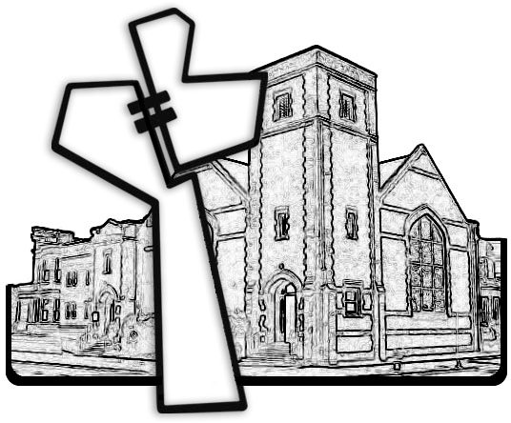



Chicago Community Mennonite Church

425 S. Central Park Blvd. (at Congress), Chicago, Illinois 60624-3224

www.ccmcil.org **|** facebook.com/ccmcil

**Church Council Chair:** Jason Gerig, 773-949-4496, jgerig@gmail.com

**Pastor:** Megan Ramer, 773-343-4251, pastor@ccmcil.org

Chicago Community Mennonite Church

June 15, 2014