Chicago Community Mennonite Church

May 4, 2014

Gathering

Prelude

Call to Worship

HWB 503 *Come, O thou Traveler unknown*

Welcome

Lighting the Peace Lamp

Prayer for Peace

Praising

HWB 349 *Spirit of the living God*

Psalm 116:1-4

Children’s Time

STS 98 *On the journey to Emmaus*

Receiving the Word

Luke 24:13-35

One: For the Word of God in scripture;   
for the Word of God among us;   
for the Word of God within us:

**All: Thanks be to God.**

Meditation

Responding

STS 39 *Will you come and follow me*

Offering

Sharing

Prayer

Sending

Announcements

STS 57 *Go, my friends, in grace*

Benediction

Extinguishing the Peace Lamp

One: Now the light of Christ is in you.

**All: Thanks be to God.**

|  |
| --- |
| Worship Participants  Worship Leaders: Benjamin Anderson and  Justin Hochstetler  Meditation: Carol Rose  Song Leader: Dan Bertsche  Pianist: Kiva Nice-Webb  Altar: Brooke Hutchison |

Announcements

**Pastor Megan on Sabbatical:** Megan is on sabbatical and will be unavailable until her return on Sunday, June 8. If you are in need of pastoral care in her absence, please contact Celeste Groff (312-505-9791), or a member of our Pastoral Care Team: Ross Bay (773-329-3872), Derek Becker (773-354-8553), Nancy Hostetter (773-784-7457), Jan Lugibihl (312-307-1674). More info can be found in the sabbatical packets available in our library, just behind the sanctuary.

**Fundraiser for Karena Mendoza and Jeanne Clark!** On May 10 we will gather to have fun and share our love with Karena and Jeanne. Events will include a Gala performance, silent auction, appetizers, wine and dessert. Join us from 5:30 PM – 9:30 PM at Pleasant Home (at the intersection of Pleasant and Home) in Oak Park. Bring your pocketbooks -- our goal is to raise money to help offset some of the unexpected costs incurred as a result of living with cancer and to hopefully send them on a weekend getaway (should Karena's energy allow)! If you can't attend but want to make a contribution, please make checks payable to CCMC and mark "Karena Fundraiser" in the memo line. For more info, contact Sara Reschly.

**CDC Family Day:** The Central District Conference West congregations (which includes us!) have organized a Family Day in Madison WI on Thursday, June 26 prior to the CDC annual meeting. Events include a Run/Walk/Bike-a-thon at 1:00 PM, a picnic at 5:30, worship service at 7:30, followed by an outdoor concert and ice cream. All are welcome.

**Guess Who’s Coming to Dinner!** Have you ever felt like you ran out of time to chat during fellowship hour?Have a desire to deepen your connect with CCMC people ?

Then this is for you!

* Who: Anyone interested in connecting more with fellow CCMCers
* What: Sign up to host or attend a lunch, then wait in anticipation to meet your dinner companions.
* When: Sunday, May 18, 2014 (after church)
* Where: In host’s homes. We’ll send an email the week of telling you where you’ll be dining.

Interested CCMCers should sign up with your name and number attending or number you can host.  There will be a sign-up sheet downstairs during fellowship hour.

**Christian Peacemaker Teams Prayer for Peacemakers:** Pray for the people of At-Tuwani, who remain steadfast in their resistance to occupation, although settlements continue to confiscate lands they have depended on for their livelihood.

Schedules

|  |  |  |
| --- | --- | --- |
|  | **Today** | **Next Sunday** |
| **Greeter:** | Derek Becker | Merle Baker |
| **Nursery:** | Jan Lugibihl  Martin Dyrst | Linda Becker  Josiah Groff |
| **Fellowship:** | Paul Myers  Rosalynn Gingerich | Katie VanderHeide |
| **Welcome Table:** | Potluck | Josiah Groff  Ruby Campos |



Chicago Community Mennonite Church

425 S. Central Park Blvd. (at Congress), Chicago, Illinois 60624-3224

www.ccmcil.org **|** facebook.com/ccmcil

**Church Council Chair:** Jason Gerig, 773-949-4496, jgerig@gmail.com

**Pastor:** Megan Ramer, 773-343-4251, pastor@ccmcil.org

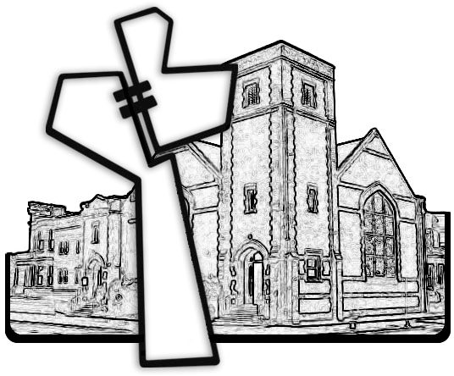

Chicago Community Mennonite Church

May 4, 2014