Chicago Community Mennonite Church

May 25, 2014

Gathering

Prelude

Call to Worship

One: God of gods: We come to worship today

and to hear your good news,

**All: to hear of faith, hope and love**

One: ringing out from your kingdom.

**All: We know that doubt, fear and hatred**

One: can shake even the strongest.

**All: Shape us into faithful, hopeful people,**

One: fill us with your love that passes all understanding.

**All: We pray this together in the name of Jesus Christ, Amen.**

STS 100 *Oh blessed spring*

Welcome

Lighting the Peace Lamp

Prayer for Peace

Praising

STJ 61 *How can we be silent*

Children’s Time

STJ 32 *If you believe and I believe*

Receiving the Word

Psalm 68:8-20

John 14:15-21

One: For the Word of God in scripture;   
for the Word of God among us;   
for the Word of God within us:

**All: Thanks be to God.**

Meditation

Responding

Offering

STS 121 *Nothing is lost on the breath of God*

Sharing

Prayer

Sending

Announcements

HWB 653 *Abide with me*

Benediction

One: Go here in the knowledge that you do not go alone:

the power and presence of God goes with you.

**All: Thanks be to God.**

Extinguishing the Peace Lamp

One: Now the light of Christ is in you.

**All: Thanks be to God.**

|  |
| --- |
| Worship Participants  Worship Leaders: Benjamin Anderson  Meditation: Jan Lugibihl  Song Leader: Philip Kendall  Pianist: Steve Warkentin  Altar: Janet Friesen |

Announcements

**Church Picnic June 1:** CCMC will have our Annual Picnic on   
June 1. This is an opportunity to thank Sunday School Teachers and spend a lovely afternoon in Garfield Park. Bring your own plate, silverware, blanket or chair and a dish to share. The Fellowship Committee will provide ice, water, lemonade and cups. If it rains,   
we will have our picnic inside the church.

**Adult Education today:** *LGBTQ Safe Space Training: Continuing the Conversation*. As a Welcoming congregation, our Mennonite Voluntary Service program identifies itself as a Safe Space for GLBTQ persons. During Second Hour today we will discuss what CCMC's identity as a Safe Space look like, and what are our corporatecommitments to further developing Safe Space?

**Already done with your spring cleaning?**Well the Fellowship Committee asks you to dig once more into your cupboards and donate a mug or two toward our dwindling collection used during the Fellowship-hot-drink-Time.  We could use standard size mugs that can stack in our limited storage location. (Not too small, not too tall-not sure? Bring it in anyway.)  You can leave your mug(s) on the island counter by the sink.  Thanks for helping us go green!

**Pastor Megan on Sabbatical:** Megan is on sabbatical and will be unavailable until her return on Sunday, June 8. If you are in need of pastoral care in her absence, please contact Celeste Groff (312-505-9791), or a member of our Pastoral Care Team: Ross Bay (773-329-3872), Derek Becker (773-354-8553), Nancy Hostetter (773-784-7457), Jan Lugibihl (312-307-1674). More info can be found in the sabbatical packets available in our library, just behind the sanctuary.

Schedule

|  |  |  |
| --- | --- | --- |
|  | **Today** | **Next Sunday** |
| **Greeter:** | Josiah Groff | Russell Johnson |
| **Nursery:** | Joel Peters-Fransen  Ross Bay |  |
| **Fellowship:** | Russell Johnson | Annual Picnic |
| **Welcome Table:** | Derek Becker | Annual Picnic |

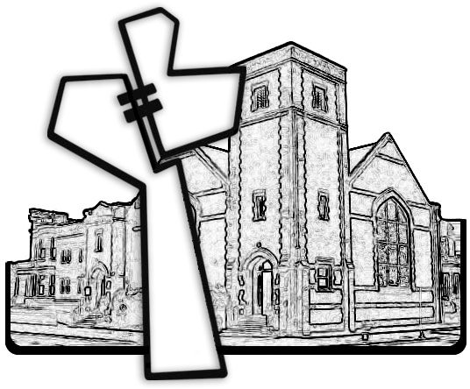



Chicago Community Mennonite Church

425 S. Central Park Blvd. (at Congress), Chicago, Illinois 60624-3224

www.ccmcil.org **|** facebook.com/ccmcil

**Church Council Chair:** Jason Gerig, 773-949-4496, jgerig@gmail.com

**Pastor:** Megan Ramer, 773-343-4251, pastor@ccmcil.org

Chicago Community Mennonite Church

May 25, 2014