Chicago Community Mennonite Church

May 18, 2014

Gathering

Prelude

Call to Worship

One: Christ is risen!

**All: Christ is risen indeed!**

One: We have every reason not to let our hearts be troubled,

Not to be afraid of anything in life or death.

**All: We are chosen, royal priests, God’s own people, ready to declare the wonderful deeds of the One who called us out of the darkness into glorious Light.**

One: Christ is risen!

**All: Christ is risen indeed!**

Welcome

Lighting the Peace Lamp

Prayer for Peace

Praising

HWB 278 *Christ is alive! Let Christians sing!*

Children’s Time

Receiving the Word

Psalm 31:1-8,15,16

HWB 327 *Great is thy faithfulness*

Acts 7:55-60

One: For the Word of God in scripture;   
for the Word of God among us;   
for the Word of God within us:

**All: Thanks be to God.**

Meditation

Responding

HWB 574 *What a friend we have in Jesus*

Offering

Sharing

Prayer

Sending

Announcements

HWB 434 *Thuma mina*

Benediction

Extinguishing the Peace Lamp

One: Now the light of Christ is in you.

**All: Thanks be to God.**

|  |
| --- |
| Worship Participants  Worship Leaders: Jan Lugibihl  Meditation: Benjamin Reynolds  Song Leader: Glenn Martin Klaassen  Pianist: Antonia Kam  Altar: Jody Schmidt |

Announcements

**Already done with your spring cleaning?**Well the Fellowship Committee asks you to dig once more into your cupboards and donate a mug or two toward our dwindling collection used during the Fellowship-hot-drink-Time.  We could use standard size mugs that can stack in our limited storage location. (Not too small, not too tall-not sure? Bring it in anyway.)  You can leave your mug(s) on the island counter by the sink.  Thanks for helping us go green!

**Adult Education in May:**

* May 18 *Guess Who's Coming to Dinner?* (no Second Hour)
* May 25 *LGBTQ Safe Space Training: Continuing the Conversation*. As a Welcoming congregation, our Mennonite Voluntary Service program identifies itself as a Safe Space for GLBTQ persons. We will discuss what CCMC's identity as a Safe Space look like, and what are our corporatecommitments to further developing Safe Space?

**Christian Peacemaker Teams Prayer for Peacemakers:** Pray that the Colombian government will fulfill its agreements with small-scale farmers who went on strike in April and May and not pursue a divide and conquer strategy as happened during last year’s agrarian strike.

**Pastor Megan on Sabbatical:** Megan is on sabbatical and will be unavailable until her return on Sunday, June 8. If you are in need of pastoral care in her absence, please contact Celeste Groff (312-505-9791), or a member of our Pastoral Care Team: Ross Bay (773-329-3872), Derek Becker (773-354-8553), Nancy Hostetter (773-784-7457), Jan Lugibihl (312-307-1674). More info can be found in the sabbatical packets available in our library, just behind the sanctuary.

Schedule

|  |  |  |
| --- | --- | --- |
|  | **Today** | **Next Sunday** |
| **Greeter:** | Rochelle Klaassen | Josiah Graff |
| **Nursery:** | Celia Goertzen  Justin Riegsecker | Joel Peters-Fransen  Ross Bay |
| **Fellowship:** | Guess Who’s Coming to Dinner | Spencer Foon  Geoff Martin |
| **Welcome Table:** | Guess Who’s Coming to Dinner | Derek Becker |

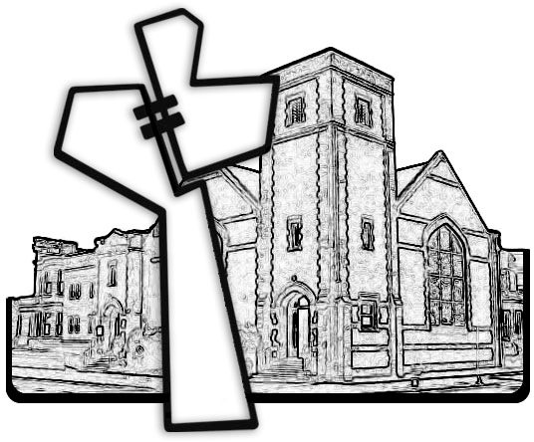



Chicago Community Mennonite Church

425 S. Central Park Blvd. (at Congress), Chicago, Illinois 60624-3224

www.ccmcil.org **|** facebook.com/ccmcil

**Church Council Chair:** Jason Gerig, 773-949-4496, jgerig@gmail.com

**Pastor:** Megan Ramer, 773-343-4251, pastor@ccmcil.org

Chicago Community Mennonite Church

May 18, 2014