Chicago Community Mennonite Church

April 6, 2014 ✢ Lent 5 ✢ From Exclusion to Inclusion

Gathering

Prelude: *Suite No. 2, Prelude* J. S. Bach

HWB 506 *I sought the Lord*

Welcome

Call to Worship

One: Jesus said, “Follow me.” We don’t always know

what that means

**Many: We are on a journey of discovery.**

**We are here because we want to be God’s people;**

One: We are here because we are broken and want to be

whole again;

**Many: We are here to celebrate our lives, and God’s**

**presence in this life.**

**All: Let us worship God with great thanksgiving.**

**Amen.**

Lighting the Peace Lamp

Prayerfor Peace

Praising

HWB 89 *For the beauty of the earth*

Psalm 130

HWB 640 *This is a day of new beginnings*

Receiving God’s Word

Children’s Time

HWB 653  *Abide with me*

Hebrews 13:1-2

John 1:1, 14

One: For the Word of God in scripture;   
for the Word of God among us;   
for the Word of God within us:

**All: Thanks be to God.**

Meditation

Responding

Special Music: *I Will Change Your Name* D.J. Butler

Offering: STJ 29

*You are all we have.*

*You give us what we need.*

*Our lives are in your hands, O Lord,*

*Our lives are in your hands.*

Sharing

Prayer

Sending

Announcements

*Listen to the Lord*

*Listen to the Lord as he speaks softly*

*Listen to the words of a perfect man*

*Listen to the miracle of God incarnate*

*Listen even when you don’t understand*

Benediction

Extinguishing the Peace Lamp

One: Now the light of Christ is in you.

**All: Thanks be to God.**

|  |
| --- |
| Worship Participants  Worship Leader: Mariell Waltner  Meditation: Megan Ramer  Song Leader: Philip Kendall  Pianist: Kiva Nice-Webb  Viola: Istvan Loga  Altar: Brooke Hutchison |

Announcements

**Lent Books – Please bring them!** If you have a copy of our Lenten book, *Spiritual Formation* by Henri Nouwen, please remember to bring it each Sunday.

**Membership Exploration Class, Sunday, April 13, 12 p.m.:** All are welcome to attend this session focused on the story of CCMC. We will meet for 90 minutes and a light lunch will be provided. RSVP with Pastor Megan (pastor@ccmcil.org) or contact with questions.

**Write an Anabaptist hymn; win a prize!** In an effort to promote songwriting among Mennonites in the U.S. and to broaden the musical spectrum, Mountain States Mennonite Conference is organizing the first Anabaptist Songwriting Challenge. Three finalists will be awarded $1,000 each. Submissions are due October 1, 2014. www.anabaptistsongwritingchallenge.org

**Inspiración Dance Chicago’s First Annual Gala, April 25:**

Susanna Hostetter invites all to experience Inspiración Dance Chicago’s Gala on April 25. Inspiración is a non-profit whose community work engages local high school and college students through Latin dance. Gala proceeds help fund this important community work. More info and tickets are available at www.inspiraciondancechicago.org/gala2014.

**Christian Peacemaker Teams Prayer for Peacemakers:** Give thanks for the successful conclusion of the training in Iraqi Kurdistan. It was an important step in changing how training is done in CPT. In addition to local participants from Iraqi Kurdistan, trainees and trainers from Poland, the Czech Republic, Germany, Sweden, Colombia, and Canada attended.

Schedules

|  |  |  |
| --- | --- | --- |
|  | **Today** | **Next Sunday** |
| **Greeter:** | Kate Myers | Katie VanderHeide |
| **Nursery:** | Brooke Hutchison  Brian Paff | Kate Myers  Nancy Hostetter |
| **Fellowship:** | Steve Jost  Jan Lugibuhl | Justin Riegsecker |
| **Welcome Table:** | Potluck | Mark Liechty  Liz Finch |



Chicago Community Mennonite Church

425 S. Central Park Blvd. (at Congress), Chicago, Illinois 60624-3224

www.ccmcil.org **|** facebook.com/ccmcil

**Church Council Chair:** Jason Gerig, 773-949-4496, jgerig@gmail.com

**Pastor:** Megan Ramer, 773-343-4251, pastor@ccmcil.org

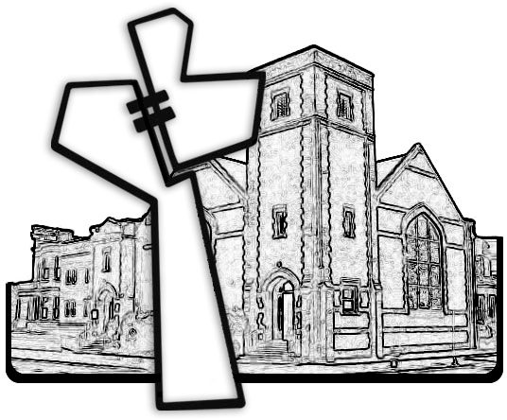

Chicago Community Mennonite Church

April 6, 2014