Chicago Community Mennonite Church

April 27, 2014

Gathering

Prelude

Call to Worship

One: We have come to this holy place to worship our

God; yet sanctuary is not always built by human

hands.

**Many: Everywhere we go is a sanctuary, every place a**

**time to worship God!**

One: When we live as if this planet and all creation,

even ourselves, is a sanctuary -- a holy place

full of the Creator's presence -- we walk differently

upon this earth. 

**Many: I am always on sacred ground.**

**I must move with reverence through all creation.**

**All: We enter this holy place now to worship the**

**Creator.**

HWB 25 *Jesus, stand among us*

Welcome

Lighting the Peace Lamp

Prayer for Peace

Praising

Psalm 16

HWB 521 *Come, thou fount*

Children’s Time

Receiving the Word

1 Peter 1:3-9

HWB 392 *Heart and mind, possessions, Lord*

John 20:19-31

One: For the Word of God in scripture;   
for the Word of God among us;   
for the Word of God within us:

**All: Thanks be to God.**

Meditation

Responding

STS 98 *On the journey to Emmaus*

Offering

Sharing

Prayer

Sending

Announcements

STS 101 *The risen Christ*

Benediction

One: Go forth in the love of God.

**Many: We will take this love**

**into unlovely parts of our lives.**

One: Go forth in the grace of Jesus Christ.

**Many: We will look for him**

**in the faces of every person we meet.**

One: Go forth in the peace of the Spirit.

**Many: We will share this hope with our broken world.**

Extinguishing the Peace Lamp

One: Now the light of Christ is in you.

**All: Thanks be to God.**

|  |
| --- |
| Worship Participants  Worship Leader: Linda Becker  Meditation: Lauren Friesen  Song Leader: Nancy Hostetter  Pianist: Steve Warkentin  Altar: Janet Friesen |

Announcements

**Second Hour today: Singledom in the Church.** A small group that has been meeting to discuss being single and Christian will engage the larger church family in a lively conversation about how best to celebrate and support one another as individuals within our community. We will meet in the Fellowship Hall during Second Hour.

**Pastor Megan on Sabbatical:** Megan is on sabbatical and will be unavailable until her return on Sunday, June 8. If you are in need of pastoral care in her absence, please contact Celeste Groff (312-505-9791), or a member of our Pastoral Care Team: Ross Bay (773-329-3872), Derek Becker (773-354-8553), Nancy Hostetter (773-784-7457), Jan Lugibihl (312-307-1674). More info can be found in the sabbatical packets available in our library, just behind the sanctuary.

**CDC Family Day:** The Central District Conference West congregations (which includes us!) have organized a Family Day in Madison WI on Thursday, June 26 prior to the CDC annual meeting. Events include a Run/Walk/Bike-a-thon at 1:00 PM, a picnic at 5:30, worship service at 7:30, followed by an outdoor concert and ice cream. All are welcome.

**Christian Peacemaker Teams Prayer for Peacemakers:** Pray for those attending CPT’s European Convergence this weekend in Aalsmeer, Netherlands and those participating in the solidarity witness with refugees and asylum-seekers at the Border Prison in Schiphol, Netherlands.  Ask that creative new strategies arise out of the gathering that will help CPT-Europe address the life and death issues of immigration at Europe’s borders.

Schedules

|  |  |  |
| --- | --- | --- |
|  | **Today** | **Next Sunday** |
| **Greeter:** | Liz Finch | Ross Bay |
| **Nursery:** | Tim Schuler  Rochelle Martin-Klaasen | Jan Lugibihl  Martin Dyrst |
| **Fellowship:** | Joanne Zimmerly | Paul Myers  Rosalynn Gingerich |
| **Welcome Table:** | Spencer Foon  Rosalynn Gingerich | Potluck |



Chicago Community Mennonite Church

425 S. Central Park Blvd. (at Congress), Chicago, Illinois 60624-3224

www.ccmcil.org **|** facebook.com/ccmcil

**Church Council Chair:** Jason Gerig, 773-949-4496, jgerig@gmail.com

**Pastor:** Megan Ramer, 773-343-4251, pastor@ccmcil.org

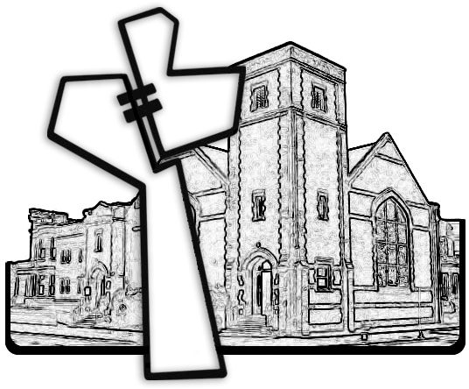

Chicago Community Mennonite Church

April 27, 2014