Chicago Community Mennonite Church

April 20, 2014 ✢ Easter Sunday

Gathering

Prelude

Call to Worship

HWB 280 *Christ the Lord has risen today*

Welcome

Lighting the Peace Lamp

Praising

Psalm 118:1-2, 14-24

Receiving New Members: Liz Finch and Sean Connor

Children’s Time

HWB 275 *Lift your glad voices*

Receiving the Word

STS 88 *That Easter morn, at break of day*

*Mysteries, Yes* Mary Oliver

John 20:1-18

One: For the Word of God in scripture;   
for the Word of God among us;   
for the Word of God within us:

**All: Thanks be to God.**

Meditation

Responding

STS 89 *Christ is alive*

Sharing

Prayer

STS 123 *Let us talent and tongues employ*

Communion

Sending

Announcements

Blessing and sending of Pastor Megan

*Mysteries, Yes* Mary Oliver

Benediction

Extinguishing the Peace Lamp

One: Now the light of Christ is in you.

**All: Thanks be to God.**

The Messiah “Hallelujah” Chorus G.F. Handel

|  |
| --- |
| Worship Participants  Worship Leader: Benjamin Anderson, Jody Schmidt  Meditation: Megan Ramer  Song Leader: Maria Paff  Pianist: Antonia Kam  Altar: Jody Schmidt |

Announcements

**Easter lunch at the Dyrst home, Today:** All are invited to the home of Liz and Martin Dyrst for Easter lunch at 12:30 P.M. today. We will make a ham. Please RSVP to lmdyrst@gmail.com.

**Prayer Service for Karena Mendoza, Tuesday, April 22, 6:00 p.m.**: This Tuesday we will gather here at the church for prayer. All ages are welcome.

**Pastor Megan’s sabbatical:** Megan’s last day in the office before leaving for her 6-week sabbatical is Thursday, April 24. She will be away and unavailable until her return on Sunday, June 8. More details in the sabbatical informational letter sent to the listserv. Contact Jason Gerig, jgerig@gmail.com, if you would like a copy.

**The Archeology of Our Faith: Unearthing Hidden Treasure**. Beginning on May 11, and continuing the second Sunday of each month, we will begin a series of brief stories that uncover legacies from our Mennonite heritage. These scenarios will highlight the unique contribution that many have made even though their lives have often been ignored and overlooked. If you know of untold stories of Mennonites who lived their faith boldly, creatively or in any other unique manner, please share those with Lauren Friesen (lfriesen@umich.edu). If you would like to be one of the readers, also contact Lauren.

**Christian Peacemaker Teams Prayer for Peacemakers:** Give thanks that Ontario’s Ministry of Natural Resources has decided not to issue logging permits on Grassy Narrows (Asubpeeschoseewagong) traditional lands this year, and that the EACOM and Weyerhaeuser corporations have decided not to purchase lumber from Grassy Narrows' traditional lands.  Pray that justice will be done next month when the case goes to Canada’s highest court in Ottawa that will focus on whether Ontario has the right to issue permits on traditional lands, which First Nations believe are protected by a treaty agreements.

Schedules

|  |  |  |
| --- | --- | --- |
|  | **Today** | **Next Sunday** |
| **Greeter:** | Kurt Frymire  Rosalynn Gingerich | Liz Finch |
| **Nursery:** | Bob Hostetter  Antonia Kam | Tim Schuler  Rochelle Martin-Klaassen |
| **Fellowship:** | Rochelle Martin-Klaassen | Joanne Zimmerly |
| **Welcome Table:** | Merle Baker  Sara Reschly | Spencer Foon  Rosalynn Gingerich |



Chicago Community Mennonite Church

425 S. Central Park Blvd. (at Congress), Chicago, Illinois 60624-3224

www.ccmcil.org **|** facebook.com/ccmcil

**Church Council Chair:** Jason Gerig, 773-949-4496, jgerig@gmail.com

**Pastor:** Megan Ramer, 773-343-4251, pastor@ccmcil.org

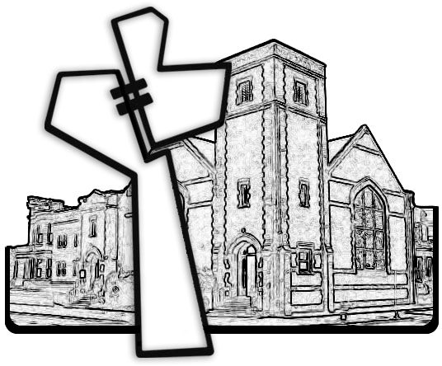

Chicago Community Mennonite Church

April 20, 2014