Chicago Community Mennonite Church

April 13, 2014 ✢ Palm / Passion

From Denying to Befriending Death

Gathering

Prelude

Call to worship

One: We tell your story

We follow in your footsteps

**All: Lead us Into Holy Week**

One: We walk towards the city, we wait in the garden

**All: Lead us onto Holy Ground**

One: We journey towards death, we hope for resurrection

**All: Lead us into Holy Joy**

HWB 237 *All glory, laud, and honor* (v. 1,3,4)

Welcome

Lighting the Peace Lamp

Announcements

Liturgy of the Palms

STS 74 *Hosanna! Hosanna!*

Matthew 21.1-11

Children’s Time

HWB 238 *Hosanna, loud hosanna*

Responding & Preparing

Prayer of Confession (STS 169)

Words of Assurance (Rom. 8:35,37-39)

Reflection

STS 121 *Nothing is lost on the breath of God*

Sharing

Prayer

Offering (tune: HWB 526 *In the rifted Rock I’m resting*)

*When I’m lonely and defenseless, my heart longs for rest and peace.*

*Then you spread your wings of caring, with your love you cover me.*

*Under your soft wings of mercy, my soul rests and is renewed,*

*for you shelter me with kindness, keep me covered, close to you.*

Liturgy of the Passion

Matthew 27.11-14

STS 85 *Lay down your head*

Matthew 27.32-46

STS 82 *How long, O Lord*

Matthew 27.47-54

One: For the Word of God in scripture,

for the Word of God among us,

for the Word of God within us;

**All: thanks be to God.**

HWB 252 *O sacred Head, now wounded* (v. 1,2,4,5)

Sending

Benediction

Extinguishing the Peace Lamp

One: Now the light of Christ is in you.

**All: Thanks be to God.**

|  |
| --- |
| Worship Participants  Worship Leader: Megan Ramer  Song Leader: Glenn Martin Klaassen  Pianist: Beth Peachey  Altar: Antonia Kam |

Announcements

**Holy Week Services**

* + Thursday: First Church’s Maundy Thursday service, 6:30 p.m.
  + Friday: Joint service with First Church and La Roca, 6:30 p.m.
  + Sunday: Easter worship, please bring your *Messiah* score!

**Prayer Service for Karena Mendoza**: On Tues. April 22 at 6:00 p.m. we will gather here at the church for prayer. Children welcome.

**Pastor Megan’s 6-week Sabbatical**: Megan’s last day in the office is Thurs. April 24. She will be away and unavailable until her return on Sun. June 8. More details in the sabbatical info letter sent to the listserv. Contact Jason, jgerig@gmail.com, if you would like a copy.

**Pilsen MVS House: sharing our stories.** In this week’s Second Hour we will have the privilege and opportunity to get better acquainted with the Mennonite Voluntary Service volunteers: Anna Hershey, Becky Longhurst, Lauren Stoltzfus, and Nathan Vader, and one associate and former volunteer: Carmen Kingsley.

**The Archeology of Our Faith: Unearthing Hidden Treasure**. CCMC will begin a series of brief segments (3-5 min) that focus on the life-story of someone who has contributed to our Mennonite heritage. Beginning on May 11 this series will continue the second Sunday of each month. These scenarios will highlight the unique impact that many have made even though their lives have often been ignored and overlooked. If you know of untold stories of Mennonites who lived their faith boldly, creatively or in any other unique manner, please share those with Lauren Friesen who will be the initial researcher and coordinator for this series. If you would like to be one of the readers, also contact Lauren, lfriesen@umich.edu.

**Christian Peacemaker Teams Prayer for Peacemakers:** Pray for the safety of Sor María Sampayo, a leader of the Organización Femenina Popular (OFP) in Colombia, who received a threatening phone call this week from someone who identified himself as Alirio Torresa, commander of the neo-paramilitary group Los Urabeños.

Schedules

|  |  |  |
| --- | --- | --- |
|  | **Today** | **Next Sunday** |
| **Greeter:** | Katie VanderHeide | Kurt Frymire  Rosalynn Gingerich |
| **Nursery:** | Kate Myers  Nancy Hostettler | Bob Hostetter  Antonia Kam |
| **Fellowship:** | Justin Riegsecker | Rochelle Martin Klaassen |
| **Welcome Table:** | Mark Liechty  Liz Finch | Merle Baker  Sara Reschly |



Chicago Community Mennonite Church

425 S. Central Park Blvd. (at Congress), Chicago, Illinois 60624-3224

www.ccmcil.org **|** facebook.com/ccmcil

**Church Council Chair:** Jason Gerig, 773-949-4496, jgerig@gmail.com

**Pastor:** Megan Ramer, 773-343-4251, pastor@ccmcil.org

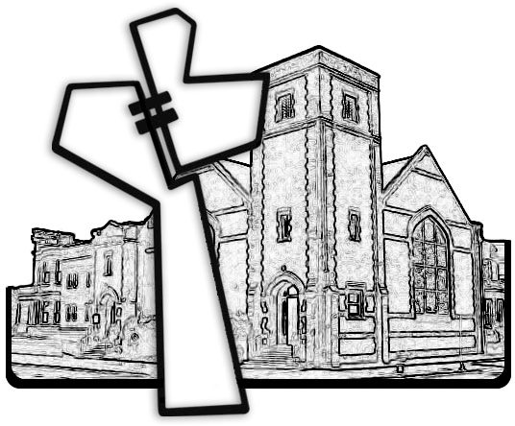

Chicago Community Mennonite Church

April 13, 2014