Chicago Community Mennonite Church

March 30, 2014 ✢ Lent 4 ✢ From Resentment to Gratitude

Gathering

Prelude

HWB 506 *I sought the Lord*

Welcome

Call to Worship

Lighting the Peace Lamp

Prayer

Praising

HWB 45 *I cannot dance, O Love*

Psalm 27

HWB 64 *Asithi: Amen*

Receiving God’s Word

Children’s Time: Dedication of Kids Care Quilt

STS 71  *Gentle God, when we are driven*

Matthew 20:1-16

One: For the Word of God in scripture; for the Word of God among us; for the Word of God within us:

**All: Thanks be to God.**

Meditation

Responding

STS 62 *Create in my a clean heart*

Sharing

Communion

Sending

Announcements

*Listen to the Lord*

*Listen to the Lord as he speaks softly*

*Listen to the words of a perfect man*

*Listen to the miracle of God incarnate*

*Listen even when you don’t understand*

Benediction

Extinguishing the Peace Lamp

One: Now the light of Christ is in you.

**All: Thanks be to God.**

|  |
| --- |
| Worship Participants  Worship Leader: Kiva Nice-Webb  Meditation: Megan Ramer  Song Leader: Philip Kendall  Pianist: Maria Paff  Altar: Janet Friesen |

Announcements

**Lent Books – Please bring them!** If you have a copy of our Lenten book, *Spiritual Formation* by Henri Nouwen, please remember to bring it each Sunday.

**Adult Education Multi-track Series: March 30**

* Discussion of the Morning’s Sermon / Worship Experience, Laura Hostetler leads, room 1B
* Climate Change & Renewable Energy: Our Scenarios,   
  Duane Ediger leads, Fellowship Hall
* Exploring Our Larger Church Family, Megan Ramer leads, room 2A

**Membership Exploration Class, Sunday, April 13, 12 p.m.:** All are welcome to attend this session focused on the story of CCMC. We will meet for 90 minutes and a light lunch will be provided. RSVP with Pastor Megan (pastor@ccmcil.org) or contact with questions.

**CCMC Service Day, Saturday, April 26**: The Peace, Justice and Service Committee invites all skilled and unskilled laborers to join us in Rebuilding Together, April 26. Activities may include stripping, painting, installing, sweeping, sealing, and repairing. There may be some preparation work needed before April 26 – so if you are unavailable that day but want to be involved, let us know! To participate and receive a team T-shirt, fill out a hard-copy volunteer form (available during fellowship time) and submit to Brooke Hutchison, Thais Carter, Tim Schuler or Allison Schuler by April 2.

**Fall 50:** Interested in running “the most scenic distance run in the Midwest”? Linda Becker and Jason Gerig are committed to running the Fall 50, a 50-mile relay in Door County, WI on Saturday, October 25. Teams of up to five split the distance among themselves. While one is running, the rest drive together to the next hand-off spot. Registration is April 1 – and it sells out quick – so let Linda or Jason know ASAP if you’re interested. www.fall50.com

**Christian Peacemaker Teams Prayer for Peacemakers:** Pray for the families living near buildings in Al-Khalil (Hebron) that Israeli settlers have targeted for takeover. Settler occupation of these structures will lead to sharp increases in hardships and violence for the neighborhoods in which they are located.

**A new day off for Pastor Megan:**I have shifted my day off from Monday to Friday. I will be in the office Monday-Thursday. If you ever have an emergency during my Friday-Saturday weekly Sabbath, please contact a member of the Pastoral Care Team (Nancy Hostetter, Ross Bay, Derek Becker, Jan Lugibihl) or Jason Gerig. They know how to reach me if need be. Thank you!

Schedules

|  |  |  |
| --- | --- | --- |
|  | **Today** | **Next Sunday** |
| **Greeter:** | Justin Hochstetler | Kate Myers |
| **Nursery:** | Steve Jost  Mark Frey | Brooke Hutchison  Brian Paff |
| **Fellowship:** | Kate Myers | Steve Jost  Jan Lugibuhl |
| **Welcome Table:** | Megan Ramer  Mariell Waltner | Potluck |



Chicago Community Mennonite Church

425 S. Central Park Blvd. (at Congress), Chicago, Illinois 60624-3224

www.ccmcil.org **|** facebook.com/ccmcil

**Church Council Chair:** Jason Gerig, 773-949-4496, jgerig@gmail.com

**Pastor:** Megan Ramer, 773-343-4251, pastor@ccmcil.org

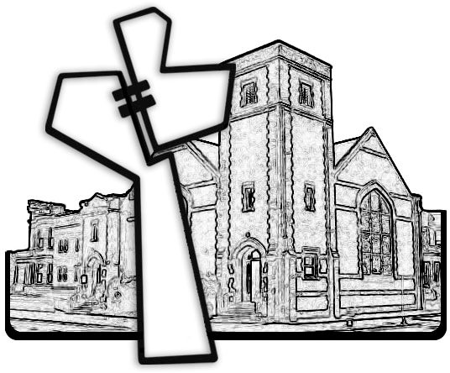

Chicago Community Mennonite Church

March 30, 2014