Chicago Community Mennonite Church

March 23, 2014 ✢ Lent 3 ✢ From Sorrow to Joy

Gathering

Prelude

HWB 10 *Jesus, we want to meet*

Welcome

HWB 30 *Spirit divine, inspire our prayers*

Lighting the Peace Lamp

Prayer for Peace, from STS 149

One: Eternal Spirit

Life-Giver,

Pain-Bearer,

Love-Maker,

Source of all that is and that shall be,

Father and Mother of us all,

Loving God, in whom is heaven;

**All: The hallowing of your name**

**echo through the universe.**

**The way of your justice be followed**

**by the peoples of the world.**

**Your heavenly will be done**

**by all created beings.**

**Your commonwealth of peace and freedom**

**sustain our hope**

**and come on earth. Amen.**

Praising

Psalm 126

HWB 506 *I sought the Lord*

Receiving God’s Word

Reading *On Joy and Sorrow*  Kahil Gibran

Children’s Time

Luke 24:13-35

One: For the Word of God in scripture;   
for the Word of God among us;   
for the Word of God within us:

**All: Thanks be to God.**

Meditation

Responding

HWB 552 *By gracious powers*

Offering: STJ 60 *Lord of all good*

Sharing

Prayer

STJ 59 *Come and fill our hearts*

Sending

Announcements

*Listen to the Lord*

*Listen to the Lord as he speaks softly*

*Listen to the words of a perfect man*

*Listen to the miracle of God incarnate*

*Listen even when you don’t understand*

Benediction

Extinguishing the Peace Lamp

One: Now the light of Christ is in you.

**All: Thanks be to God.**

|  |
| --- |
| Worship Participants  Worship Leader: Hannah Klaassen  Meditation: Philip Kendall  Song Leader: Nancy Hostetter  Pianist: Steve Warkentin  Altar: Janet Friesen |

Announcements

**Lent Books – Please bring them!** If you have a copy of our Lenten book, *Spiritual Formation* by Henri Nouwen, please remember to bring it each Sunday. Worship leaders and/or preachers may call your attention to the artwork contained therein.

**Membership Exploration Class, Sunday, April 13, 12 p.m.:** All are welcome to attend this session focused on the story of CCMC. We will meet for 90 minutes and a light lunch will be provided. RSVP with Pastor Megan (pastor@ccmcil.org) or contact with questions.

**Adult Education Multi-track Series: March 23 and 30**

* Discussion of the Morning’s Sermon / Worship Experience, Laura Hostetler leads, room 1B
* Climate Change & Renewable Energy: Our Scenarios,   
  Duane Ediger leads, Fellowship Hall
* Exploring Our Larger Church Family (March 23 and 30), Megan Ramer leads, room 2A

**Christian Peacemaker Teams Prayer for Peacemakers:** Pray for the upcoming CPT Europe delegation in April, which will focus on the violence and injustice refugees and migrants face on Europe’s outer borders. Pray also for the families of the seven migrants who drowned this week when the boat they were sailing on from Turkey sank in the Aegean Sea.

**A new day off for Pastor Megan:**I have decided shift my day off from Monday to Friday. Starting this week, I will be in the office Monday - Thursday. If you ever have an emergency during my Friday-Saturday weekly Sabbath, please contact a member of the Pastoral Care Team (Nancy Hostetter, Ross Bay, Derek Becker, Jan Lugibihl) or Jason Gerig. They know how to reach me if need be. Thank you!

Schedules

|  |  |  |
| --- | --- | --- |
|  | **Today** | **Next Sunday** |
| **Greeter:** | Geoff Martin | Justin Hochstetler |
| **Nursery:** | Phil Cordes  Hannah Klaassen | Steve Jost  Mark Frey |
| **Fellowship:** | Geoff Martin  Spencer Foon | Kate Myers |
| **Welcome Table:** | Mark Frey  Russell Johnson |  |



Chicago Community Mennonite Church

425 S. Central Park Blvd. (at Congress), Chicago, Illinois 60624-3224

www.ccmcil.org **|** facebook.com/ccmcil

**Church Council Chair:** Jason Gerig, 773-949-4496, jgerig@gmail.com

**Pastor:** Megan Ramer, 773-343-4251, pastor@ccmcil.org

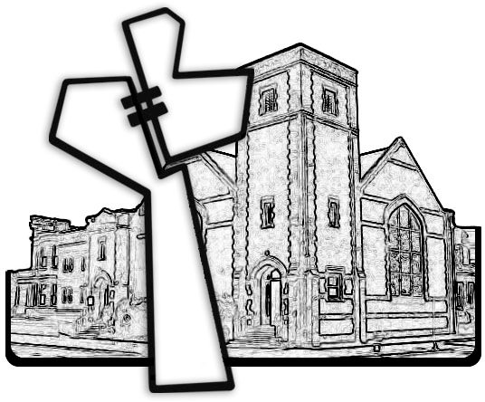

Chicago Community Mennonite Church

March 23, 2014