Chicago Community Mennonite Church

March 16, 2014 ✢ Lent 2 ✢ From Illusion to Prayer

Gathering

Prelude

Call to Worship: HWB 663

Welcome

STS 61 *O God, to whom then shall I turn?*

Lighting the Peace Lamp

Prayer for Peace

Praising

Psalm 121

HWB 506 *I Sought the Lord*

Receiving God’s Word

Mark 1:32-39

HWB 500 *As the Heart with Eager Yearning*

Matthew 6:25-34

One: For the Word of God in scripture;   
for the Word of God among us;   
for the Word of God within us:

**All: Thanks be to God.**

Children’s Time

HWB 556 *Lord, Thou hast searched me*

Meditation

Responding

HWB 495 *O let all who thirst*

Offering: *Come, Thou Fount of Every Blessing* Sara Groves

Sharing

Prayer

Sending

Announcements

*Listen to the Lord*

*Listen to the Lord as he speaks softly*

*Listen to the words of a perfect man*

*Listen to the miracle of God incarnate*

*Listen even when you don’t understand*

Benediction

Extinguishing the Peace Lamp

One: Now the light of Christ is in you.

**All: Thanks be to God.**

|  |
| --- |
| Worship Participants  Worship Leader and Meditation: Nancy McCann Hostetter  Song Leader: Beth Peachy  Pianist: Maria Paff  Visual Arts: Jody Schmidt |

Announcements

**Lent Books – Please bring them!** If you have a copy of our Lenten book, *Spiritual Formation* by Henri Nouwen, please remember to bring it each Sunday. Worship leaders and/or preachers may call your attention to the artwork contained therein.

**Pastor Megan’s travel schedule:** Pastor Megan will be out of the office until Sunday, March 23.

**Adult Education Multi-track Series: March 16, 23, and 30**

* Discussion of the Morning’s Sermon / Worship Experience, Laura Hostetler leads, room 1B
* Climate Change & Renewable Energy: Our Scenarios,   
  Duane Ediger leads, Fellowship Hall
* Exploring Our Larger Church Family (March 23 and 30), Megan Ramer leads, room 2A
* Music Workshop: Exploring Our Supplemental Song Books (March 16), Maria Paff leads

**Membership Exploration Class, Sunday, April 13, 12 p.m.:** All are welcome to attend this session focused on the story of CCMC. We will meet for 90 minutes and a light lunch will be provided. RSVP with Pastor Megan (pastor@ccmcil.org) or contact with questions.

**Christian Peacemaker Teams Prayer for Peacemakers:** Pray for the families of missing and murdered Indigenous women in Canada, and for the Canadian authorities to begin taking violence against Indigenous women seriously.

**A new day off for Pastor Megan:**I have decided shift my day off from Monday to Friday. Starting the week of March 23, I will be in the office Monday - Thursday. If you ever have an emergency during my Friday-Saturday weekly Sabbath, please contact a member of the Pastoral Care Team (Nancy Hostetter, Ross Bay, Derek Becker, Jan Lugibihl) or Jason Gerig. They know how to reach me if need be. Thank you!

Schedules

|  |  |  |
| --- | --- | --- |
|  | **Today** | **Next Sunday** |
| **Greeter:** | Jason Gerig | Geoff Martin |
| **Nursery:** | Liz Dyrst  Liz Finch | Phil Cordes  Hannah Klaassen |
| **Fellowship:** | Paul Myers | Geoff Martin  Spencer Foon |
| **Welcome Table:** | Lauren Friesen  Brian Paff | Mark Fry  Mariell Waltner |



Chicago Community Mennonite Church

425 S. Central Park Blvd. (at Congress), Chicago, Illinois 60624-3224

www.ccmcil.org **|** facebook.com/ccmcil

**Church Council Chair:** Jason Gerig, 773-949-4496, jgerig@gmail.com

**Pastor:** Megan Ramer, 773-343-4251, pastor@ccmcil.org

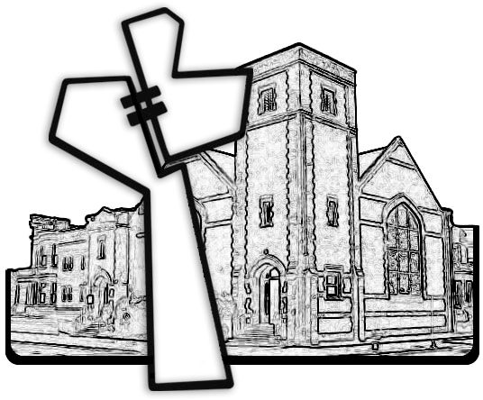

Chicago Community Mennonite Church

March 16, 2014