Chicago Community Mennonite Church

March 9, 2014 ✢ Lent 1 ✢ From Opaqueness to Transparency

Gathering

Prelude

Call to Worship

One: God of all who thirst,

Our hearts are parched from wandering in deserts

Far from your life-giving springs.

Call us to your well.

**All: Fill our cups with your grace.**

**Let your love overflow in our hearts,**

**And make us fully alive. Amen**

Welcome

STS 60 *Come To Me, Come To Us*

Lighting the Peace Lamp

Prayer for Peace – Litany of Commitment

One: Choose this day whom you will serve

**All: We will choose the living God.**

One: The road is narrow that leads to life;

**All: We will walk the Way of Christ.**

One: Faith is not our holding on;

**All:**  **Faith is our letting go.**

One: We offer more than words, O God;

**All: We offer you our lives.**

Praising

Psalm 32

HWB 506 *I Sought the Lord*

Receiving God’s Word

Luke 9:28-35

One: For the Word of God in scripture; for the Word of God among us; for the Word of God within us:

**All: Thanks be to God.**

Children’s Time

STS 55 *Love the Lord Your God*

Meditation

Responding

STS 39 *Will You Come and Follow Me*

Offering: *We Come* Jim Croegaert

Sharing

Prayer

Sending

Announcements

*Listen to the Lord*

*Listen to the Lord as he speaks softly*

*Listen to the words of a perfect man*

*Listen to the miracle of God incarnate*

*Listen even when you don’t understand*

Benediction – Litany of Commitment

Extinguishing the Peace Lamp

One: Now the light of Christ is in you.

**All: Thanks be to God.**

|  |
| --- |
| Worship Participants  Worship Leader: Sara Reschly  Meditation: Megan Ramer  Song Leader: Glenn Martin Klaassen  Visual Arts: Carol Rose |

Announcements

**Membership Exploration Class, Sunday, April 13, 12 p.m.:** All are welcome to attend this session focused on the story of CCMC. We will meet for 90 minutes and a light lunch will be provided. RSVP with Pastor Megan (pastor@ccmcil.org) or contact with questions.

**Lent Books – Please bring them!** If you have a copy of our Lenten book, *Spiritual Formation* by Henri Nouwen, please remember to bring it each Sunday. Worship leaders and/or preachers may call your attention to the artwork contained therein.

**Pastor Megan’s travel schedule:** I leave this week to officiate the wedding of a dear friend and enjoy a vacation in Hawaii. I will be out of the office for two weeks, returning Sunday, March 23

**A new day off for Pastor Megan:**I have decided shift my day off from Monday to Friday. Starting the week of March 23, I will be in the office Monday - Thursday. If you ever have an emergency during my Friday-Saturday weekly Sabbath, please contact a member of the Pastoral Care Team (Nancy Hostetter, Ross Bay, Derek Becker, Jan Lugibihl) or Jason Gerig. They know how to reach me if need be. Thank you!

**Adult Education Multi-track Series: March 9, 16, 23, 30**

* Discussion of the Morning’s Sermon / Worship Experience, Laura Hostetler leads, room 1B
* Climate Change & Renewable Energy: Our Scenarios,   
  Duane Ediger leads, Fellowship Hall
* Exploring Our Larger Church Family (March 9, 23 and 30), Megan Ramer leads, room 2A
* Music Workshop: Exploring Our Supplemental Song Books (March 16), Maria Paff leads

**Christian Peacemaker Teams Prayer for Peacemakers:** Pray for the community of Guayabo, Colombia, which successfully resisted an eviction in November, but still fears the intervention of illegal outside armed actors.

Schedules

|  |  |  |
| --- | --- | --- |
|  | **Today** | **Next Sunday** |
| **Greeter:** | Julia Rohan | Jason Gerig |
| **Nursery:** | Laura Hostetler  Joanne Zimmerly | Liz Dyrst  Liz Finch |
| **Fellowship:** | Russell Johnson | Paul Myers |
| **Welcome Table:** | Jason Gerig  Laura Hostetler | Lauren Friesen  Brian Paff |



Chicago Community Mennonite Church

425 S. Central Park Blvd. (at Congress), Chicago, Illinois 60624-3224

www.ccmcil.org **|** facebook.com/chicagocommunitymennonite

**Church Council Chair:** Jason Gerig, 773-949-4496, jgerig@gmail.com

**Pastor:** Megan Ramer, 773-343-4251, pastor@ccmcil.org

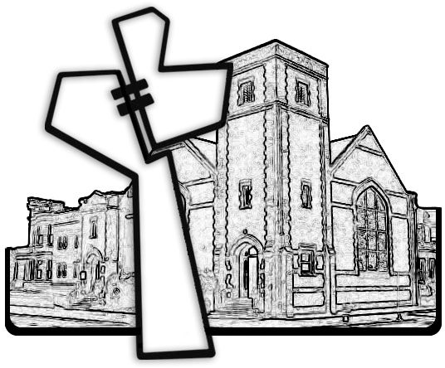

Chicago Community Mennonite Church

March 9, 2014