Chicago Community Mennonite Church

March 2, 2014

Gathering

Prelude

Call to Worship: HWB 753

Welcome

HWB 220 *Worship the Lord in Beauty*

Lighting the Peace Lamp

Prayer for Peace

Praising

Psalm 15

STS 39 *Will You Come and Follow Me*

Dedication of our Heritage Sampler congregational care quilt

Children’s Time

Receiving God’s Word

Matthew 5:1-12

HWB 229 *New Earth, Heavens New*

Micah 6:1-8

One: For the Word of God in scripture; for the Word of God among us; for the Word of God within us:

**All: Thanks be to God.**

Meditation

Responding

STS 54 *What Does the Lord Require of You*

Offering

Blessing our Church Council

Sharing

Prayer

Sending

Announcements

STS 124 *My Soul Cries Out*

Benediction

Extinguishing the Peace Lamp

One: Now the light of Christ is in you.

**All: Thanks be to God.**

|  |
| --- |
| Worship Participants  Worship Leader: Mark Frey  Meditation: Megan Ramer  Pianist: Kiva Nice-Webb  Song Leader: Dan Bertsche  Altar: Brooke Hutchinson |

Announcements

**Join us for a potluck today!** Whether or not you have brought a dish to share, you are warmly invited to share in a potluck meal with us immediately following the service.

**Ash Wednesday Service, Wed. March 5, 6:30 p.m.:** Come for a meditative evening service including the imposition of ash. We will gather with members of First Church for this service that begins the season of Lent.

**Lent book:** Our planning team has chosen a Lenten theme – *Spiritual Formation: Following the Movements of the Spirit*, based on the book of compiled writings by Henri Nouwen. We invite you to join us in reading the book as a companion to our worship. If you would like to read along, we encourage you to begin looking for a copy of the book now.

**Our women’s Spirit Feast group** would like to extend an invitation to women to join our group which meets monthly for dinner and spiritual sustenance. Please contact Sara Reschly if you're interested or would like any more information: sarareschly@gmail.com

**Christian Peacemaker Teams Prayer for Peacemakers:** Give thanks for the participants currently involved with the Iraqi Kurdistan training, and ask the Holy Spirit to fill both the trainers and trainees undergoing the training.

Schedules

|  |  |  |
| --- | --- | --- |
|  | **Today** | **Next Sunday** |
| **Greeter:** | Jan Lugibihl | Julia Rohan |
| **Nursery:** | Derek Becker  Maria Paff | Laura Hostetler  Joanne Zimmerly |
| **Fellowship:** | Ross Bay  Mariell Waltner | Russell Johnson |
| **Welcome Table:** | Potluck | Jason Gerig  Laura Hostetler |



Chicago Community Mennonite Church

425 S. Central Park Blvd. (at Congress), Chicago, Illinois 60624-3224

**Website:** chicagocommunitymennonite.org

**Facebook:** facebook.com/chicagocommunitymennonite

**Church Council Chair:** Jason Gerig, 773-949-4496, jgerig@gmail.com

**Pastor:** Megan Ramer, 773-343-4251, pastor@ccmcil.org

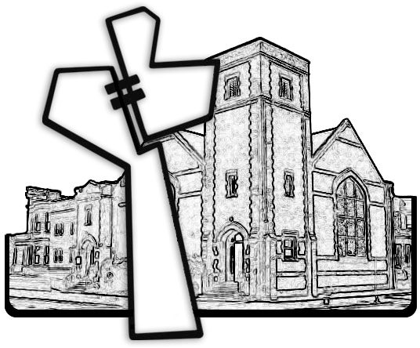

Chicago Community Mennonite Church

March 2, 2014