Chicago Community Mennonite Church  
February 23, 2014 Seventh Sunday after the Epiphany

Gathering

Prelude

Call to worship: STS 142

HWB 407 *We are people of God’s peace*

Welcome

Lighting the Peace Lamp  
Prayer for Peace

Praising

STS 1 *Praise the One who breaks the darkness*

Psalm 119:33-40

One: God teach me your ways,

**All: and I will follow them closely.**

One: Help me understand your will,

**All: that I may cherish your law.**

One: Guide me along your path,

**All: a way of delight.**

One: Open my heart to your laws,

**All: and not to riches.**

One: Turn my eyes from the lure of evil;

**All: let me live your truth.**

One: Keep your promise

**All: to one who reveres you.**

One: Spare me the shame I fear.

**All: How good your commands!**

One: See, I want what is right;

**All: let your justice give me life.**

Children’s Time  
STS 39 *Will you come and follow me* (including first optional verse between verses 2 and 3)

Receiving God’s Word

Leviticus 19:1-2, 9-18

Matthew 5:38-48

One: For the word of God in Scripture, for the word of God among us, for the word of God within us,

**All: thanks be to God.**

Meditation

Responding

HWB 408 *O day of peace*

Sharing

Prayer  
Communion

Sending

Announcements

HWB 412 *We shall walk through the valley*

Benediction

Extinguishing the Peace Lamp

One: Now the light of Christ is in you.

**All: Thanks be to God.**

|  |
| --- |
| Worship Participants  Worship Leader: Ross Bay  Meditation: Nathan Olivos Vader  Song Leader: Nancy Hostetter  Pianist: Steve Warkentin  Altar: Janet Friesen |

Announcements

**Liam Peachey’s Coming of Age Celebration, Today!** Join us to celebrate Liam’s coming of age in the Fellowship Hall following the service.

**The game is afoot!** Both worship and fellowship committees are seeking individuals who would like to join them in serving the church. Please contact Pastor Megan if you are interested or if you have questions.

**All-Church Annual Retreat, Feb. 15-16, Camp Menno Haven in Tiskilwa IL:** Mark your calendars! Church will not be meeting in Chicago on this weekend. If you would like to register or have questions please contact Sherry

**Adult Education Series - February 9 (TODAY) & 23, March 9, 16, 23, 30**

* **Discussion of the morning's Sermon / Worship Experience**

        Leader: Laura Hostetter

        Location: First Floor Classroom

* **Climate Change & Renewable Energy: Our Scenarios**

Presenter: Duane Ediger (First Church of the Brethren)

Location: Second Floor Westernmost Classroom (Choir Room)

|  |  |  |
| --- | --- | --- |
|  | **Today** | **Next Sunday** |
| **Greeter:** | Mariell Waltner | Church Retreat |
| **Fellowship:** | Rochelle Martin Klaassen | Steve Jost |
| **Welcome Table:** | Derek Becker  Jan Lugibihl | Church Retreat |

Schedules



Chicago Community Mennonite Church

425 S. Central Park Blvd. (at Congress), Chicago, Illinois 60624-3224

**Website:** chicagocommunitymennonite.org

**Facebook:** facebook.com/chicagocommunitymennonite

**Church Council Chair:** Jason Gerig, 773-949-4496, jgerig@gmail.com

**Pastor:** Megan Ramer, 773-343-4251, ccmcil@gmail.com  
**Coordinator:** Nathan Olivos Vader, nathan@chicagocommunitymennonite.org

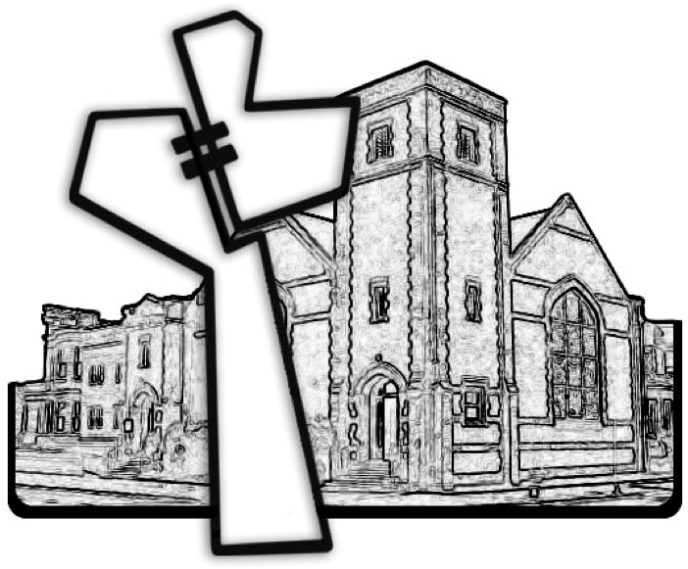

Chicago Community Mennonite Church

February 23, 2014