Chicago Community Mennonite Church

February 9, 2014

Gathering

Prelude

Welcome

Call to Worship: *To Live in the Mercy of God*

by Denise Levertov

HWB 6 *Here in this place*

Praising

Lighting the Peace Lamp

Prayer (Adapted from An Internet Prayer for Peace from Pax Christi Godweb.org)

HWB 401 *This little light of mine*

Presentation of Bible to Elias Reschly

Children’s Time

HWB 103 *Jubilate Deo omnis terra*

Receiving God’s Word

Isaiah 58

Matthew 5:13-20

One: For the word of God in Scripture, for the word of God among us, for the word of God within Us,

**All: Thanks be to God!**

Meditation

Responding

HWB 226 *You are salt for the earth*

Offering

Sharing

Prayer

Sending

Announcements

HWB 90 *For the fruit of all creation*

Benediction

One: We came to worship.

**All: We go now to serve.**

One: We have been given the light.

**All: We go now to let it shine.**

One: We have been blessed by God’s love.

**All: We go now to share it.**

One: We are Christ’s disciples.

**All: We go now to witness to all.**

Extinguishing the Peace Lamp

One: Now the light of Christ is in you.

**All: Thanks be to God.**

|  |
| --- |
| Worship Participants  Worship Leader: Jody Schmidt  Meditation: Megan Ramer  Song Leader: Glenn Martin Klaassen  Pianist: Beth Peachy  Altar: Janet Friesen |

Announcements

**This coming weekend!** All-Church Annual Retreat, Feb. 15-16, Camp Menno Haven in Tiskilwa IL. Church will **NOT** be meeting in Chicago Sun. Feb.16.

**Adult Education Series: Feb. 9 (TODAY) & 23, Mar. 9, 16, 23, 30**

* **Discussion of the morning's Sermon / worship experience**

        Leader: Laura Hostetler

        Location: Room 1E, First Floor Classroom

* **Climate Change & Renewable Energy: Our Scenarios**

Presenter: Duane Ediger (First Church of the Brethren)

Location: Room 2A, Second Floor Westernmost Classroom (Choir Room)

he Everence Sharing Funds provided $1285 in matching funds to support special needs in our congregation last year. Liz Finch serves as the Everence advocate for CCMC. Please contact her for more information.

**We host the CDC Regional Gathering, Sat. Mar. 1, 9:45 a.m. – 3:00 p.m.:** Rather than having to travel, we get to host our conference friends from the western region of CDC, including Madison, Milwaukee, greater Chicagoland, St. Paul and others. This gathering is not a delegate or business session, but a way to build connections between congregations. This year’s theme is "Transformed Through Text and Table." If you would like to come, please RSVP by Fri. Feb. 21. If you are willing to serve as a kitchen volunteer, or help contribute to a light lunch for the 20-25 attenders, please let me know! ~Pastor Megan

**Looking ahead to Lent:** Our planning team has chosen a Lenten theme – *Spiritual Formation: Following the Movements of the Spirit*, based on the book of compiled writings by Henri Nouwen. We invite you to join us in reading the book as a companion to our worship. If you would like to read along, we encourage you to begin looking for a copy of the book now.

|  |  |  |
| --- | --- | --- |
|  | **Today** | **Next Sunday** |
| **Greeter:** | Mariell Waltner | Church Retreat |
| **Fellowship:** | Rochelle Martin Klaassen | Church Retreat |
| **Welcome Table:** | Derek Becker  Jan Lugibihl | Church Retreat |

Schedules



Chicago Community Mennonite Church

425 S. Central Park Blvd. (at Congress), Chicago, Illinois 60624-3224

**Website:** chicagocommunitymennonite.org

**Facebook:** facebook.com/chicagocommunitymennonite

**Church Council Chair:** Jason Gerig, 773-949-4496, jgerig@gmail.com

**Pastor:** Megan Ramer, 773-343-4251, ccmcil@gmail.com  
**Coordinator:** Nathan Olivos Vader, nathan@chicagocommunitymennonite.org

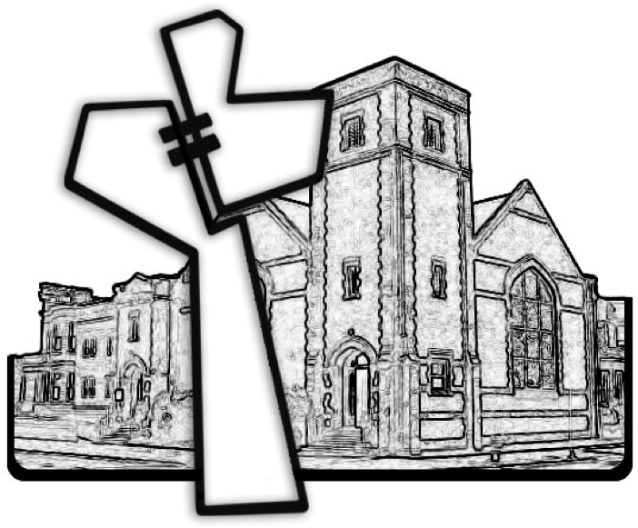

Chicago Community Mennonite Church

February 9, 2014