Chicago Community Mennonite Church

January 26, 2014

Gathering

Prelude

Welcome

Call to Worship

One: We are the body of Christ!

Baptized in one Spirit, we are members of one body.

**All: Many and varied in gender, color, age, class, and ability, we are members of Christ’s beautiful body.**

One: None of us can say to another, “I have no need of you.”

**All: For only together can we find wholeness.**

One: None of us can say to another, “I will not care for you.”

**All: For we are connected like muscle and bone.**

**If one suffers, we all suffer. If one rejoices, we all rejoice!**

One: Thanks be to God who, in Christ, has made us one.

**All: Let us worship God!**

STJ 4 *You’ve Got a Place*

Praising

Lighting the Peace Lamp

STJ 73 *One is the body*

Children’s Time

HWB 407 *We Are People of God’s Peace*

Receiving God’s Word

Acts 16:11-40

Philippians 1:3-11; 2:1-11, 19-30

One: For the word of God in Scripture, for the word of God

among us, for the word of God within us,

**All: thanks be to God.**

Meditation

Responding

HWB 307 *For We Are Strangers No More*

Offering

Reception of New Members

*Russell Johnson, Justin Riegsecker, Barbara & Michael Sacco*

Sharing

Prayer

Communion

Sending

Announcements

STJ 78 *Sizohamba naye (We will walk with God)*

Benediction

Extinguishing the Peace Lamp

One: Now the light of Christ is in you.

**All: Thanks be to God.**

|  |
| --- |
| Worship Participants  Worship Leader: Jan Lugibihl  Meditation: Megan Ramer  Song Leader: Kiva Nice-Webb  Pianist: Steve Warkentin  Altar: Brooke Hutchison |

Announcements

**Pastor Megan's travel schedule:** Megan will be joining colleagues for Pastors Week at the Anabaptist Mennonite Seminary in Elkhart IN this week. She'll be back for the weekend and fully returns to the office Tuesday February 4.

**Liam Peachey’s Coming of Age Celebration, Next Sunday!**

During the celebration on Feb 2, you'll have the chance to contribute in several ways: Contribute to a Japanese themed potluck by bringing a large pot of miso soup, a complimentary side dish or dessert, or making a monetary contribution toward the purchase of inarizushi. You are also welcome to bring a gift to mark the occasion. You'll have a chance to present your gift and say a few words about it if you wish. More details in the most recent Weekend Update sent to the listserv.

**Baptism Exploration:** If you are not yet baptized and interested in participating in a series of classes designed to help you explore that possibility, please contact Pastor Megan sometime this month. Please note that participation in a series like this does not require you to be baptized at the end. **Membership Exploration Gathering Sat Feb 1:**If you are already baptized and interested in exploring the possibility of membership at CCMC, you are invited to a gathering at Pastor Megan's home on Saturday February 1 from 1:00-2:30 p.m. (808 W Lakeside Pl #205) Please let Megan know if you plan to attend.

**Would you like to help shape our Lenten worship?** Megan is putting together a Lent planning team. The first Sunday of Lent is March 9, so we'll plan to meet Sunday Feb 2 following Liam's coming of age celebration. Please contact Megan (soon!) with questions or interest.

**The game is afoot**! Both worship and fellowship committees are seeking individuals who would like to join them in serving the church. Please contact Pastor Megan if you are interested or if you have questions.

**All-Church Annual Retreat, Feb. 15-16, Camp Menno Haven in Tiskilwa IL**: Mark your calendars! Church will not be meeting in Chicago on this weekend. If you would like to register or have questions please contact Sherry Jost.

|  |  |  |
| --- | --- | --- |
|  | **Today** | **Next Sunday** |
| **Greeter:** | Brooke Hutchinson | Becky Longhurst |
| **Fellowship:** | Josiah Groff | Jason Gerig  Katie Vanderheide |
| **Welcome Table:** | Ross Bay  Hannah Klaassen | LIAM’S COMING OF AGE |

Schedules



Chicago Community Mennonite Church

425 S. Central Park Blvd. (at Congress), Chicago, Illinois 60624-3224

**Website:** chicagocommunitymennonite.org

**Facebook:** facebook.com/chicagocommunitymennonite

**Church Council Chair:** Jason Gerig, 773-949-4496, jgerig@gmail.com

**Pastor:** Megan Ramer, 773-343-4251, ccmcil@gmail.com  
**Coordinator:** Nathan Olivos Vader, nathan@chicagocommunitymennonite.org

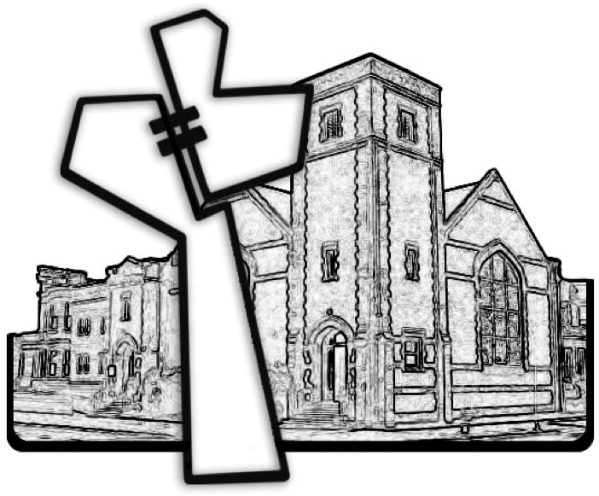

Chicago Community Mennonite Church

January 26, 2014