Chicago Community Mennonite Church

January 12, 2014

Gathering

Prelude

Welcome

Call to Worship: A Reading of Psalm 29

STJ 22 *By the waters of Babylon*

Lighting the Peace Lamp

Prayer for Peace

STJ 87 *Put Peace into each other’s hands* (vv. 1-3)

Praising

HWB 595 *Jesus priceless treasure*

Children’s Time

Receiving God’s Word

Isaiah 42: 1-9

Acts 10: 34-43

Matthew 3: 13-17

One: For the Word of God in scripture; for the Word of God among us; for the Word of God within us:

**All: Thanks be to God.**

Meditation

Responding

HWB 446 *Wade in the Water*

Offering: HWB 388

Prayer of Thanksgiving

Sharing

Prayer

Sending

Announcements

STJ 71 *Alleluia, the Great Storm is over*

Benediction

Extinguishing the Peace Lamp

One: Now the light of Christ is in you.

**All: Thanks be to God.**

|  |
| --- |
| Worship Participants  Worship Leader: Nancy McCann Hostetter  Meditation: Jeanne Clark  Song Leader: Glenn Martin-Klaassen  Pianist: Joanne Zimmerly  Altar: Antonia Kam |

Announcements

**Annual MLK Day Worship, Next Sunday Jan. 18, 10:00 a.m.:** Sleep in! And then come join us for worship with our sister congregations, First Church of the Brethren and La Iglesia Christiana Roca de Esperanza. The service will be followed by a joint potluck.

**Liam Peachey’s Coming of Age Celebration, Sunday, Feb. 2:** Please consult the listserv announcement for many more details (including food plans and gift suggestions), or contact Pastor Megan.

**The game is afoot**! Both worship and fellowship committees are seeking individuals who would like to join them in serving the church. Please contact Pastor Megan if you are interested or if you have questions.

**All-Church Annual Retreat, Feb. 15-16, Camp Menno Haven in Tiskilwa IL**: Mark your calendars! Church will not be meeting in Chicago on this weekend.

**Pastor Megan's travel schedule:**This weekend, Pastor Megan is serving the church by speaking at the Music & Worship Leaders Retreat at Laurelville Retreat Center. She is one of three preachers from different parts of the Christian tradition invited to respond to this question: What is the word that the church in the 21st century most needs to hear? She returns to the office Tuesday, January 14.

**Baptism Exploration:** If you are not yet baptized and interested in participating in a series of classes designed to help you explore that possibility, please contact Pastor Megan sometime this month. Please note that participation in a series like this does not require you to be baptized at the end. Rather, we hope it will be a true exploration and time of discernment for each member of the group.

Schedules

|  |  |  |
| --- | --- | --- |
|  | **Today** | **Next Sunday** |
| **Greeter:** | Geoff Martin |  |
| **Fellowship:** | Geoff Martin | Jan Lugibuhl |
| **Welcome Table:** | Kiva Nice-Webb  Jane Baker | MLK Joint Service Potluck |



Chicago Community Mennonite Church

425 S. Central Park Blvd. (at Congress), Chicago, Illinois 60624-3224

**Website:** chicagocommunitymennonite.org

**Facebook:** facebook.com/chicagocommunitymennonite

**Church Council Chair:** Jason Gerig, 773-949-4496, jgerig@gmail.com

**Pastor:** Megan Ramer, 773-343-4251, ccmcil@gmail.com  
**Coordinator:** Nathan Olivos Vader, nathan@chicagocommunitymennonite.org

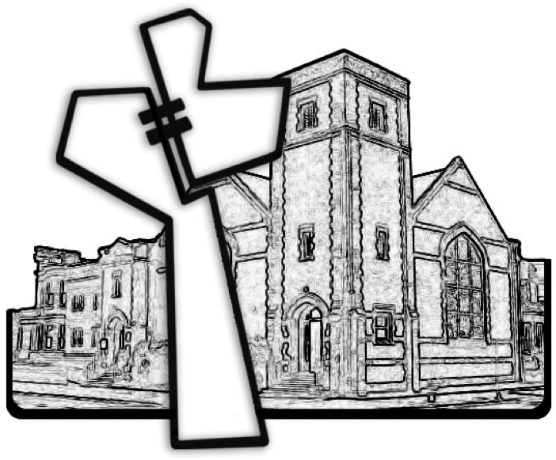

Chicago Community Mennonite Church

January 12, 2014